BDAT1007 - Assignment 2

In this assignment you will research a dataset and apply the following models in PART 1-3.

Note:

1. If you don’t like RapidMiner, feel free to complete this assignment with other tool / languages (python, pyspark, R, Tableau, Power BI, etc.)
2. This is individual work – however if you find it really challenging, you are able to pick one partner to work together – just specify it in the submission. You can only have one partner by maximum.
3. Please respect Georgian College’s Academic Integrity policy. Plagiarized work will receive 0 marks.

PART 1: Draft a generalized linear model (GLM) - 30 points

PART 2: Draft a decision tree modeling - 30 points

PART 3: Draft a logistic regression modeling - 30 points

PART 4: Explain the pros and cons of each model - 10 points

Full screenshot of your Design Process, Running Output should be submitted. Please use the same dataset for all models.

Submission

Word/pdf file to include the following:

Multiple Linear regression

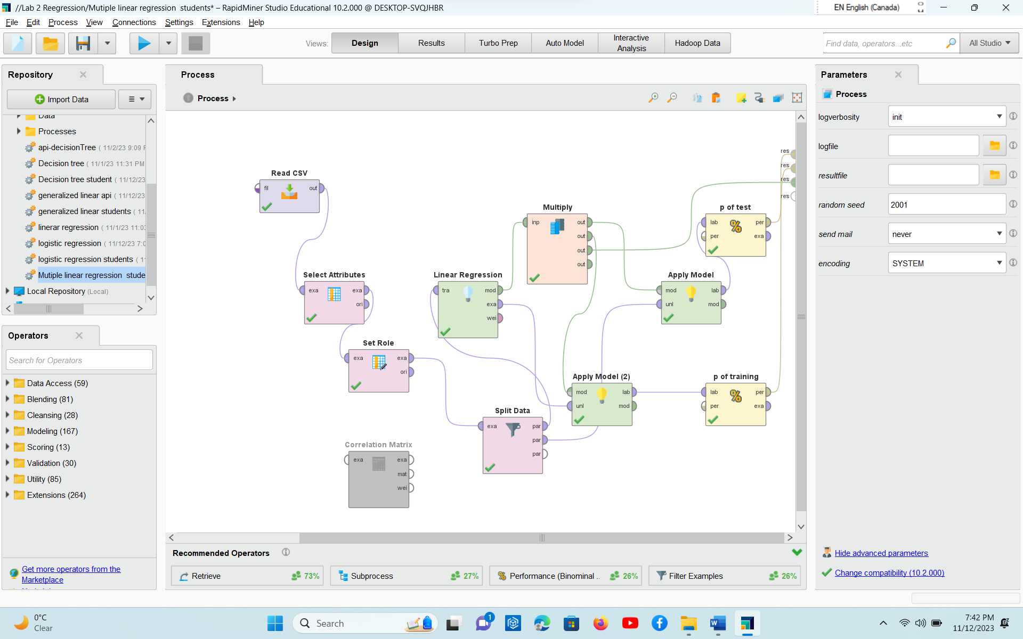

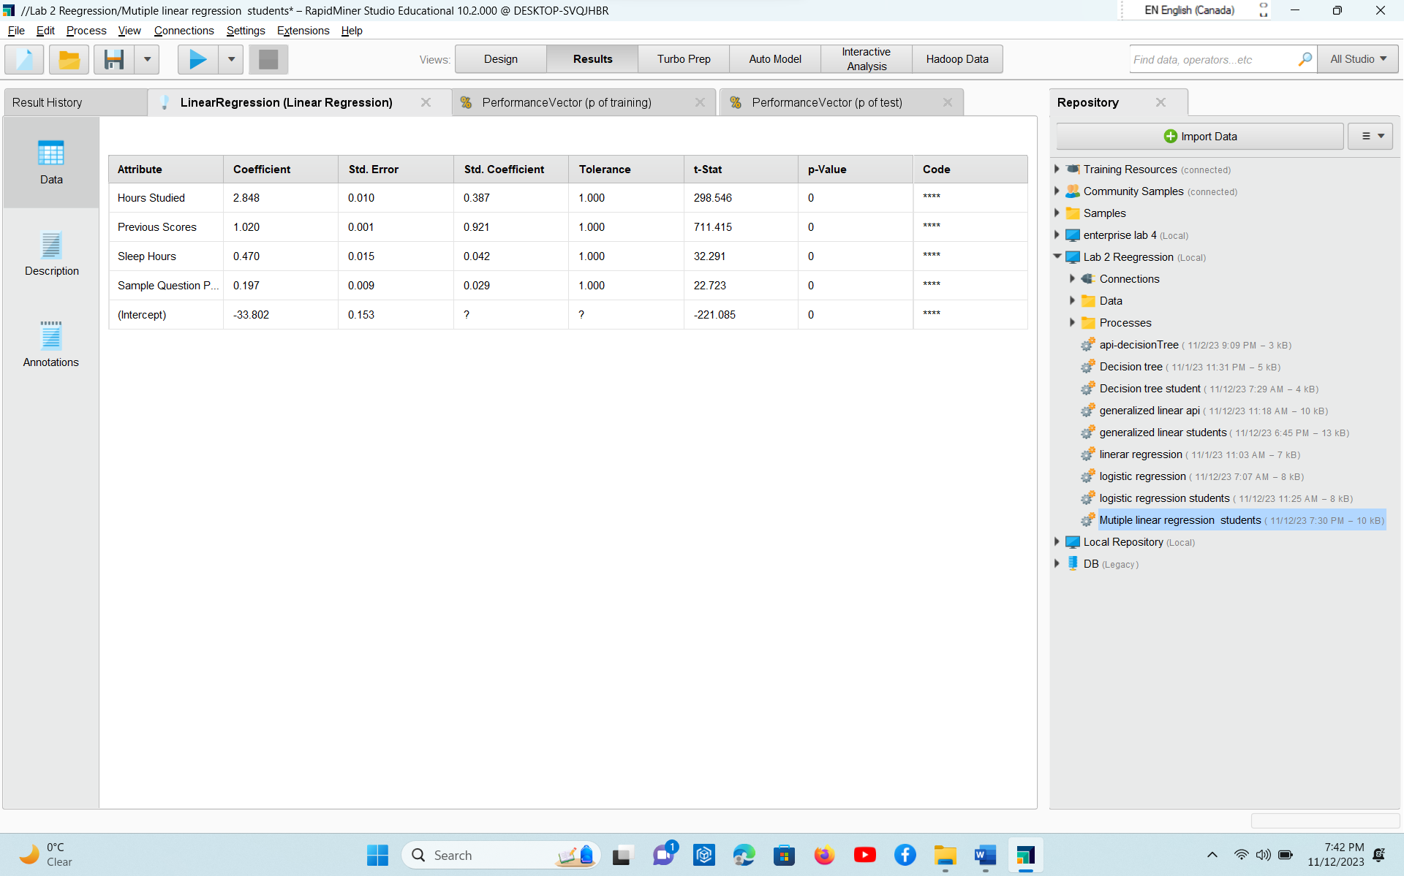

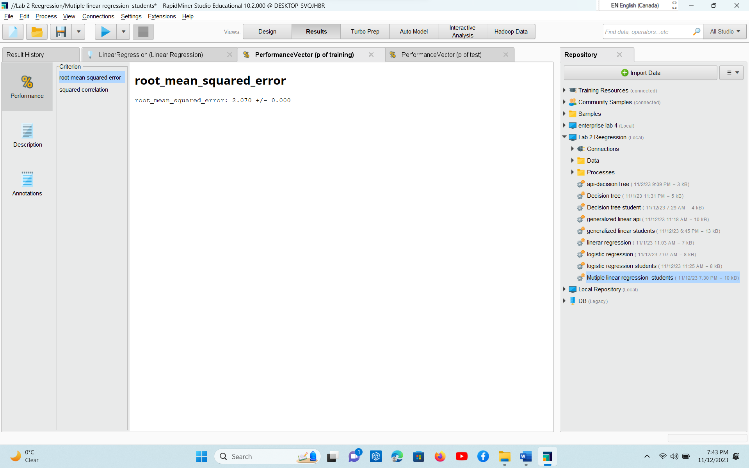

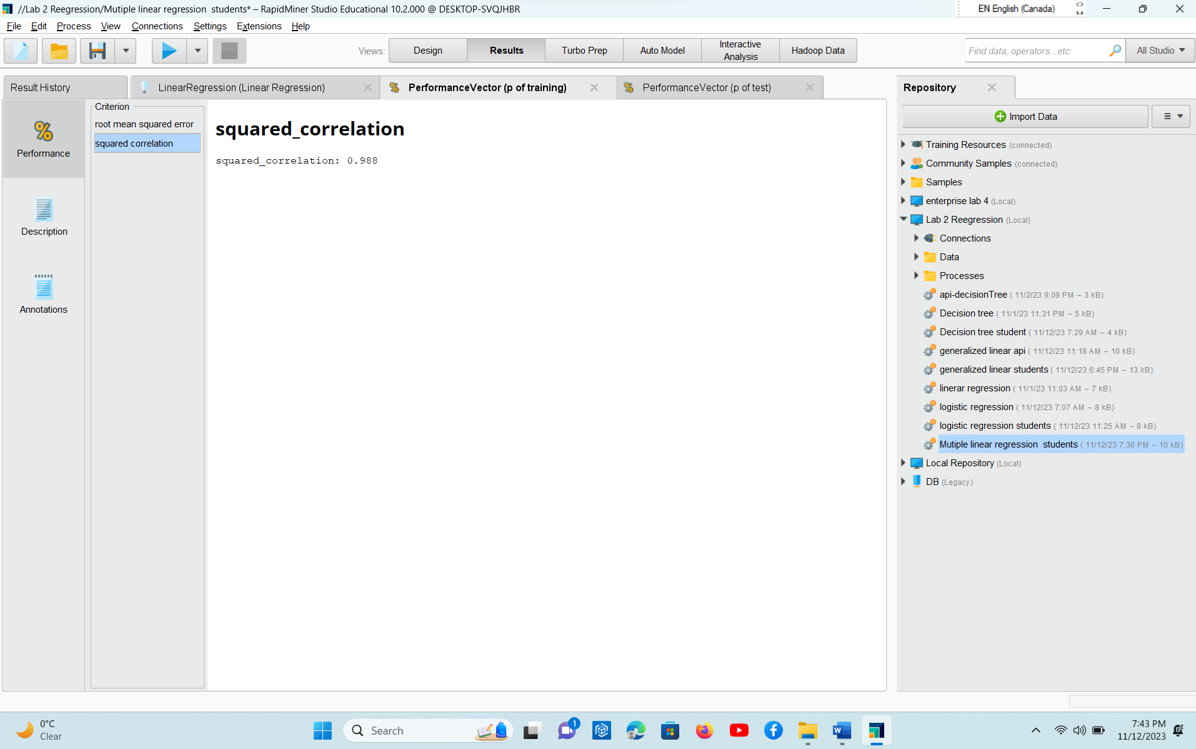

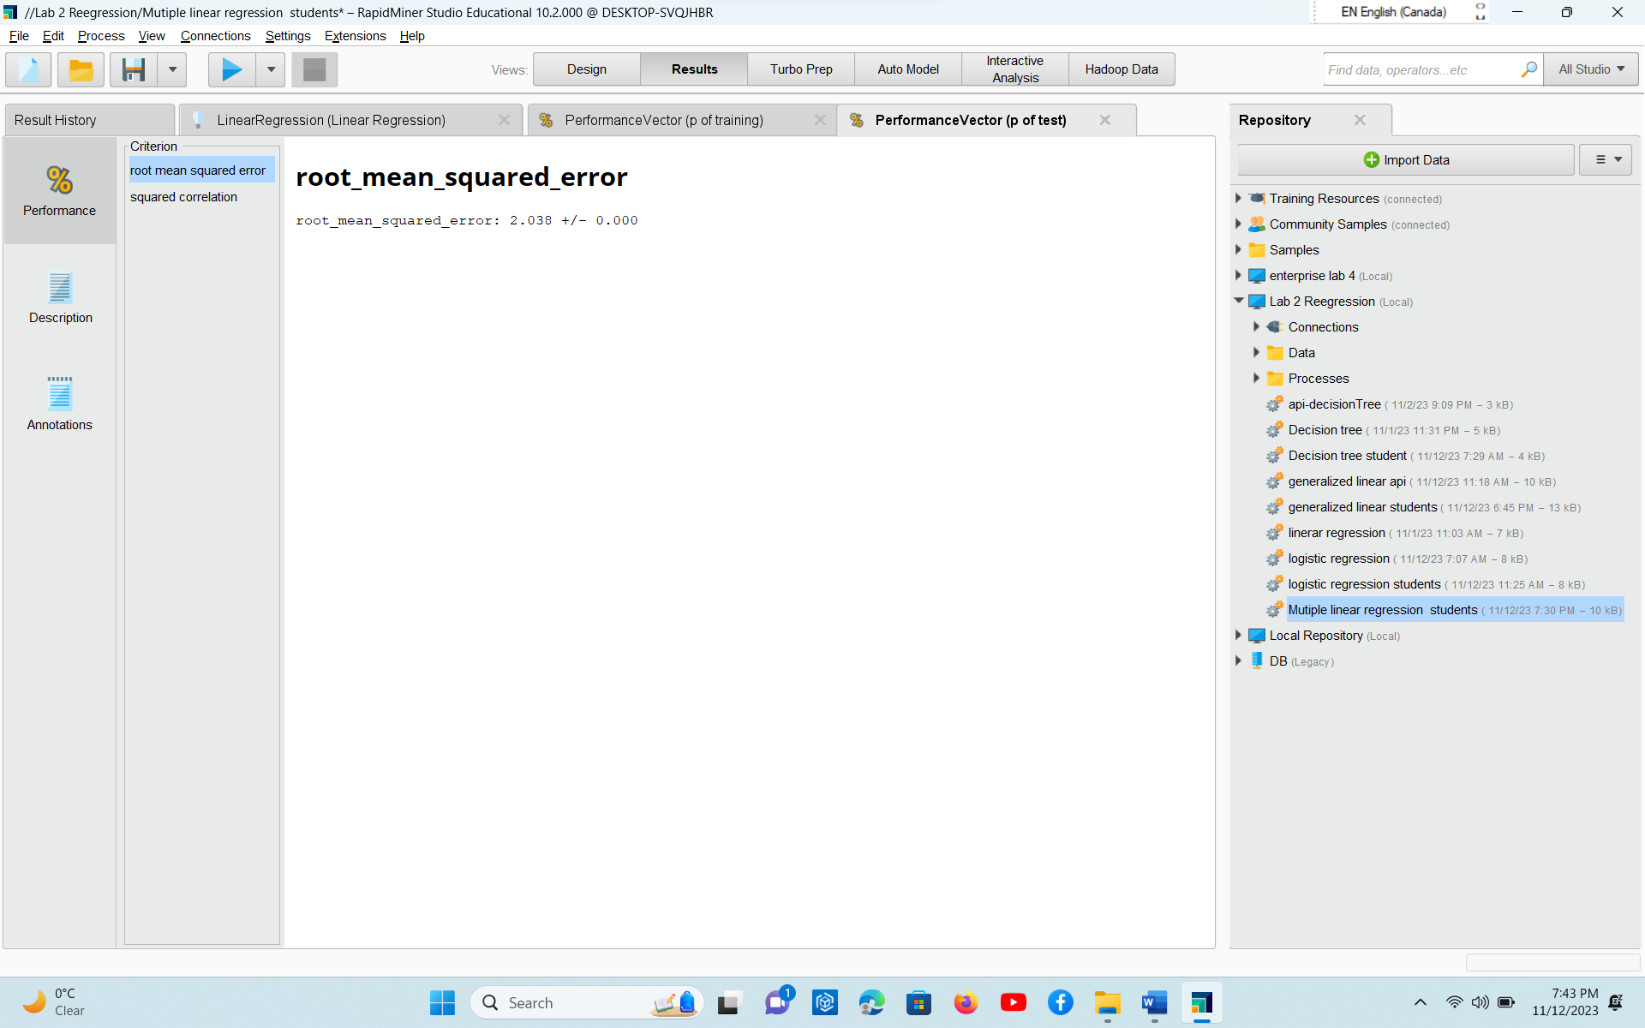

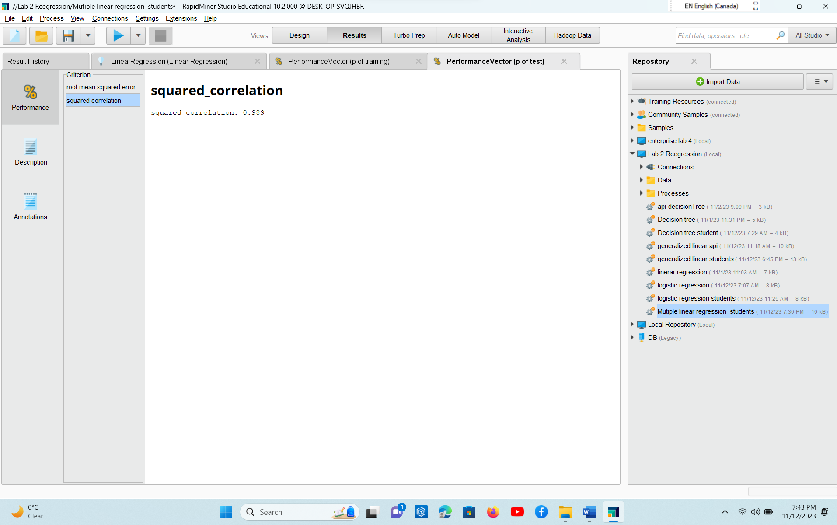

PART 1: Draft a generalized linear model (GLM) - 30 points

* Design Process completed for each PART

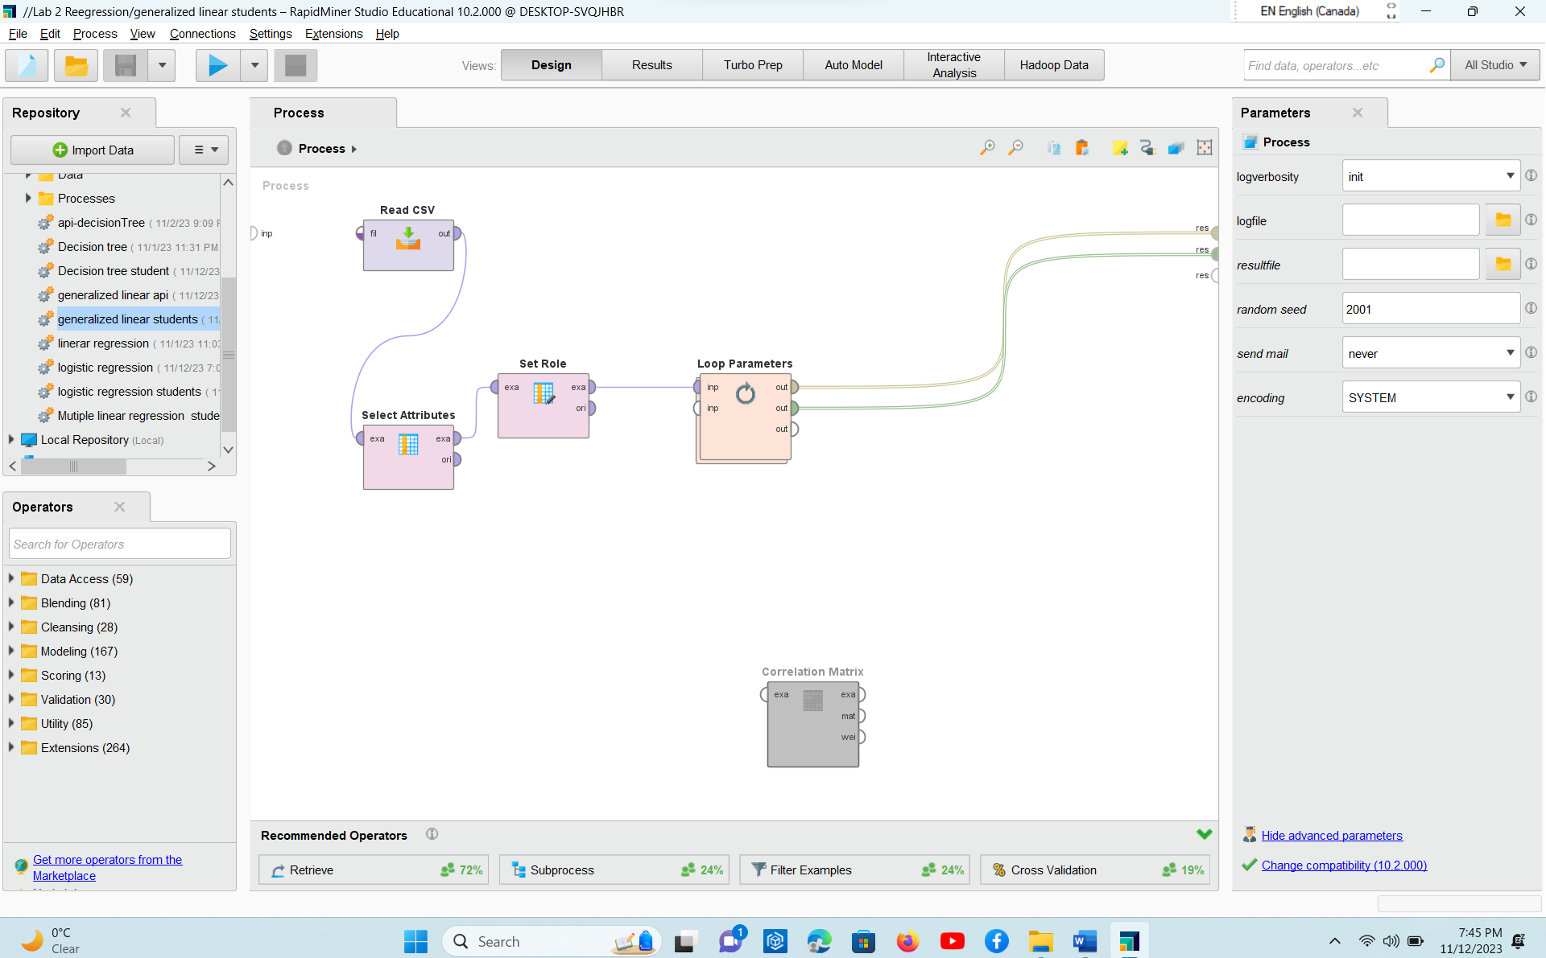

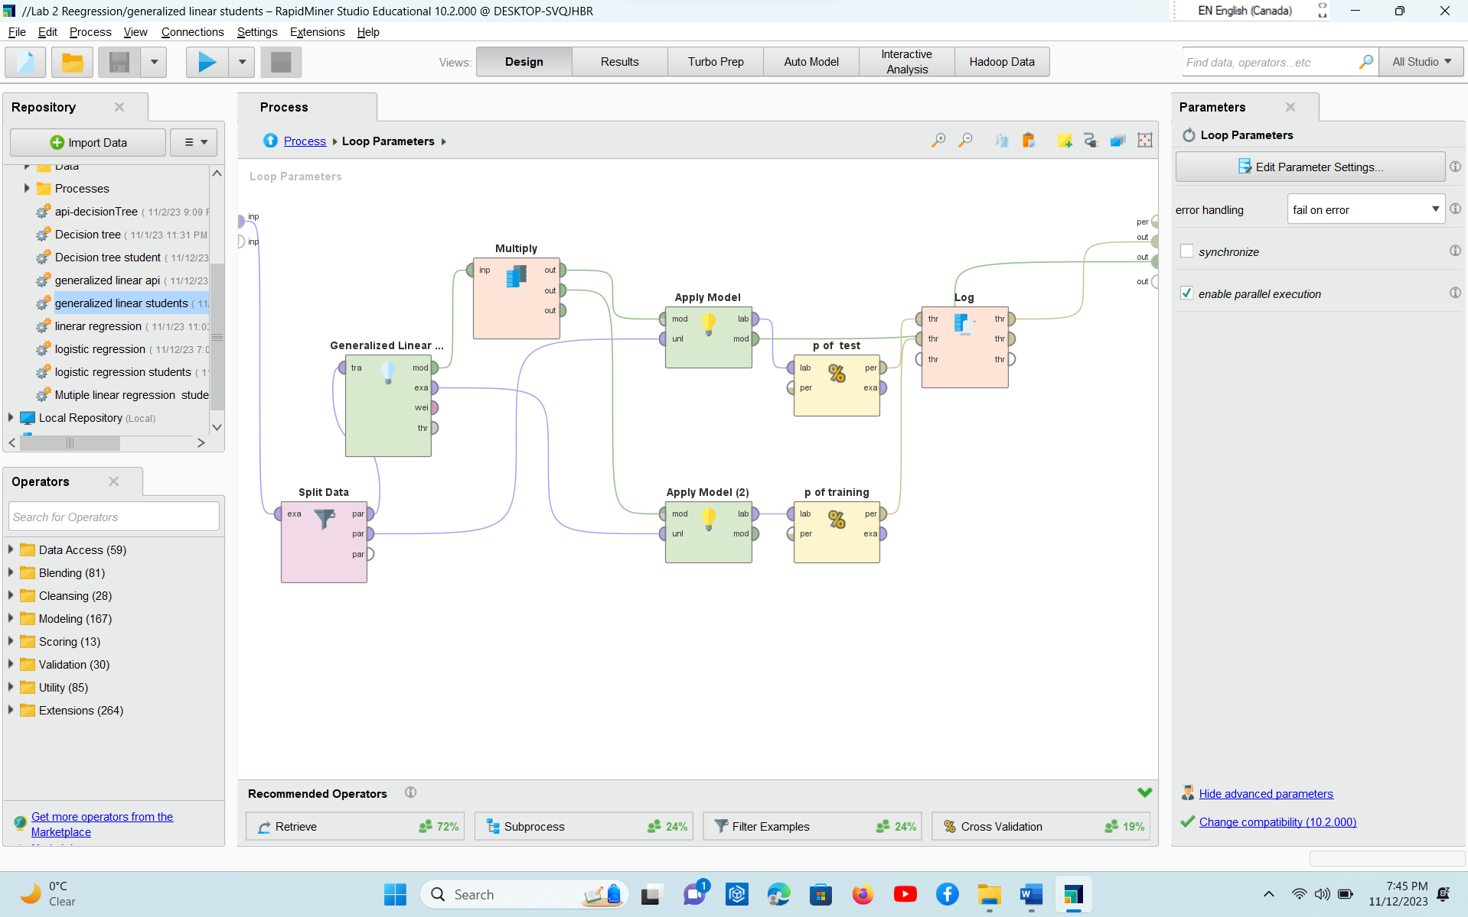

* Running Output/Results from RapidMiner (or any other tools/ languages)

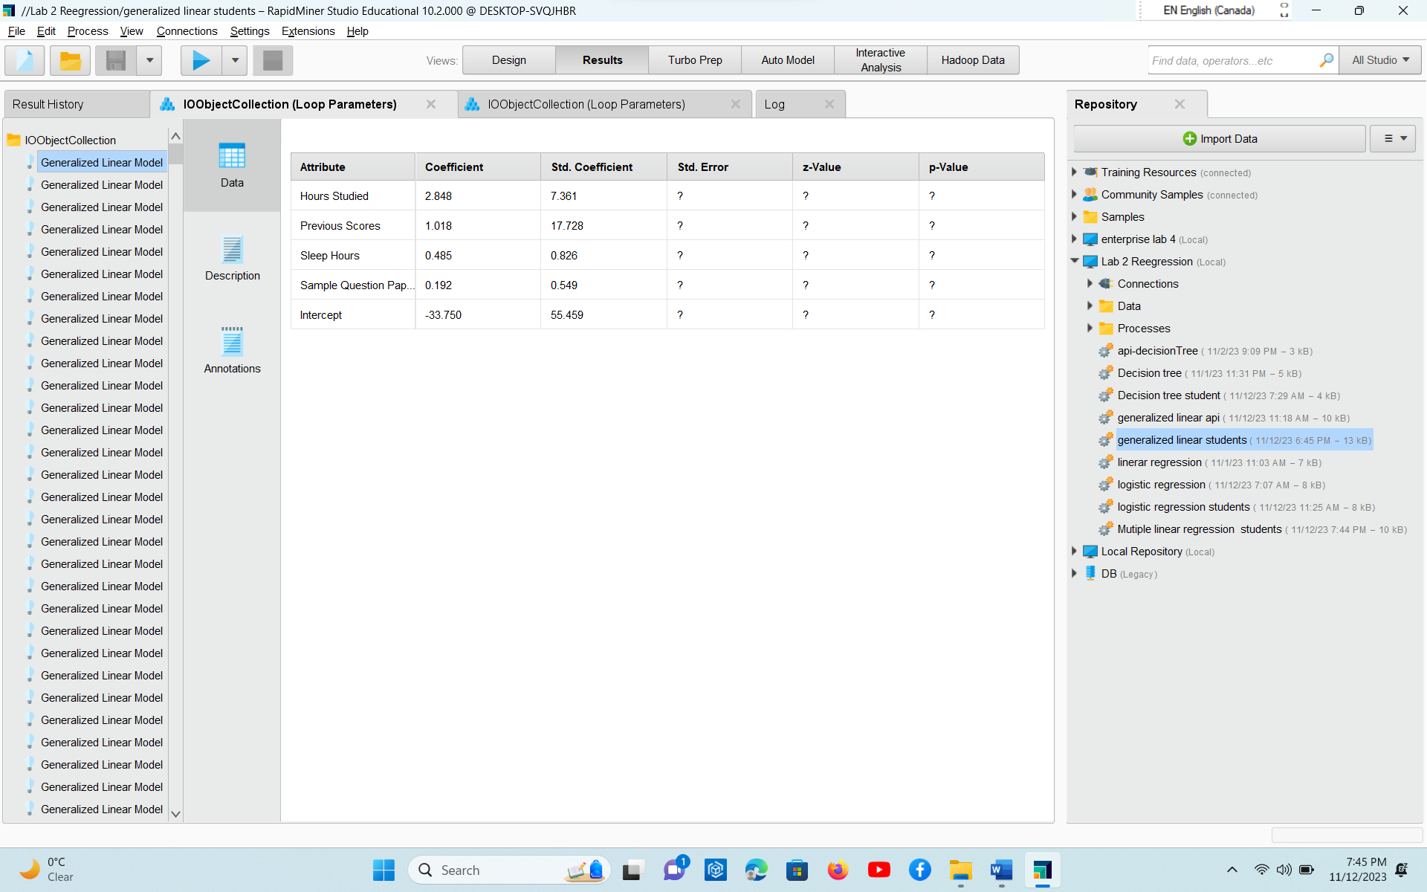

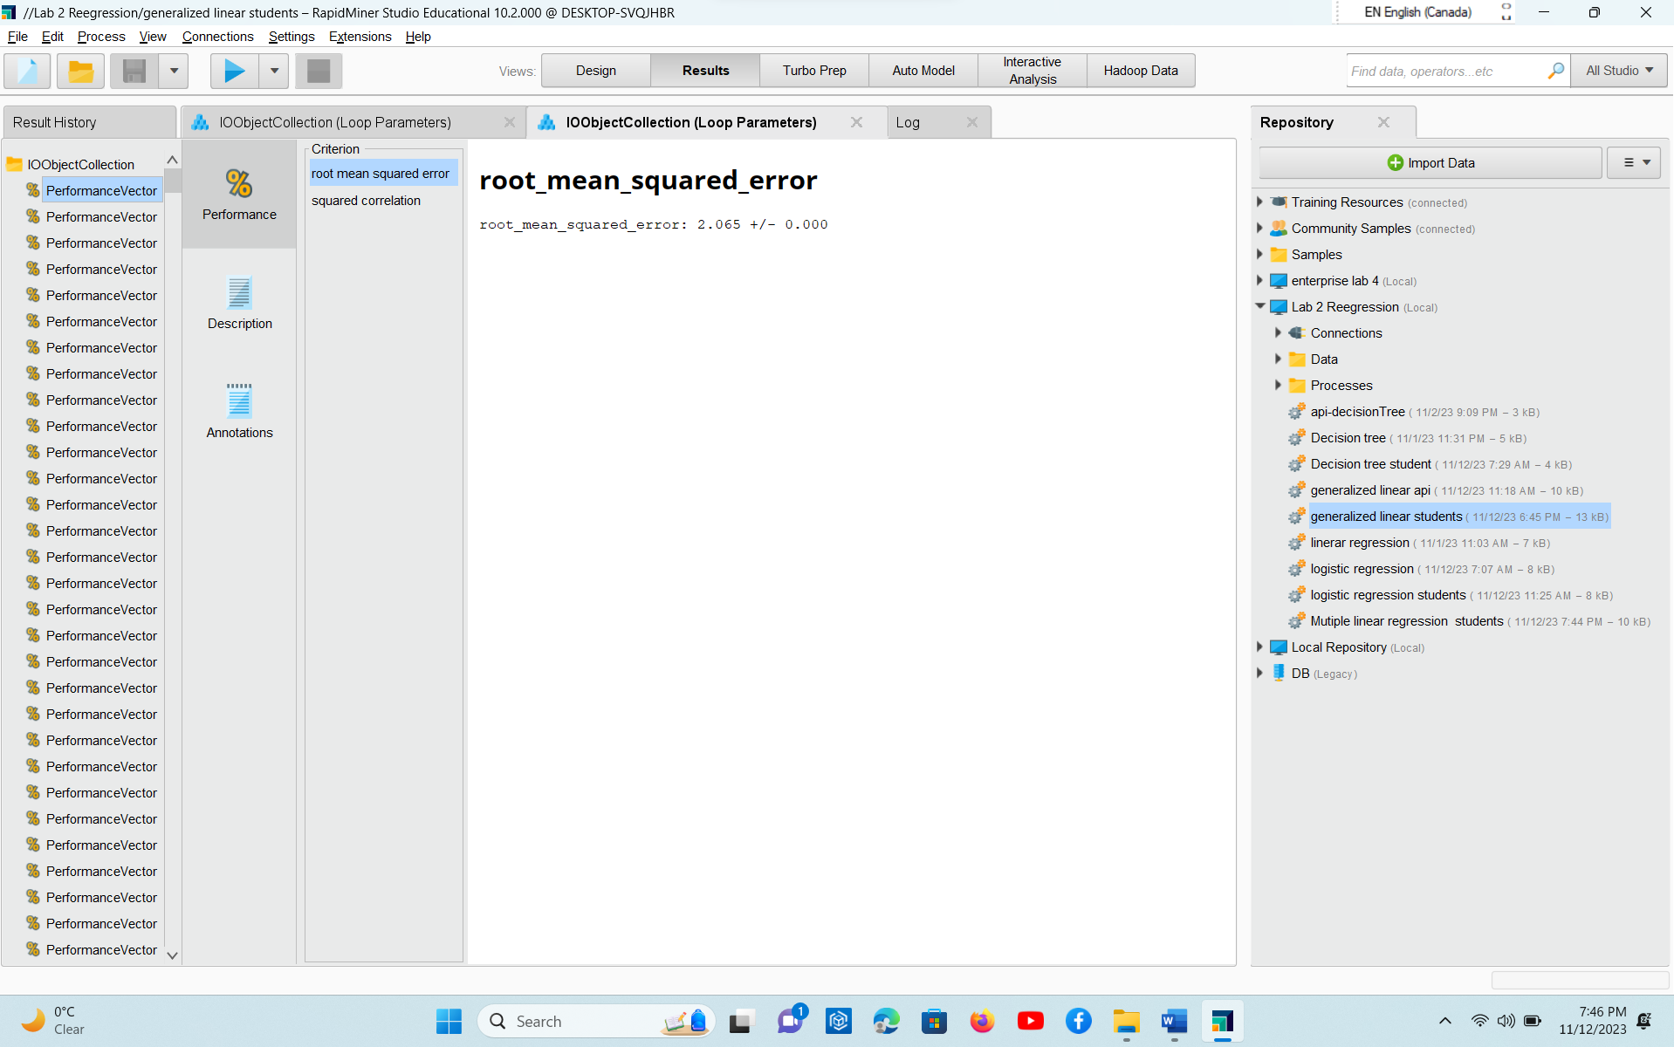

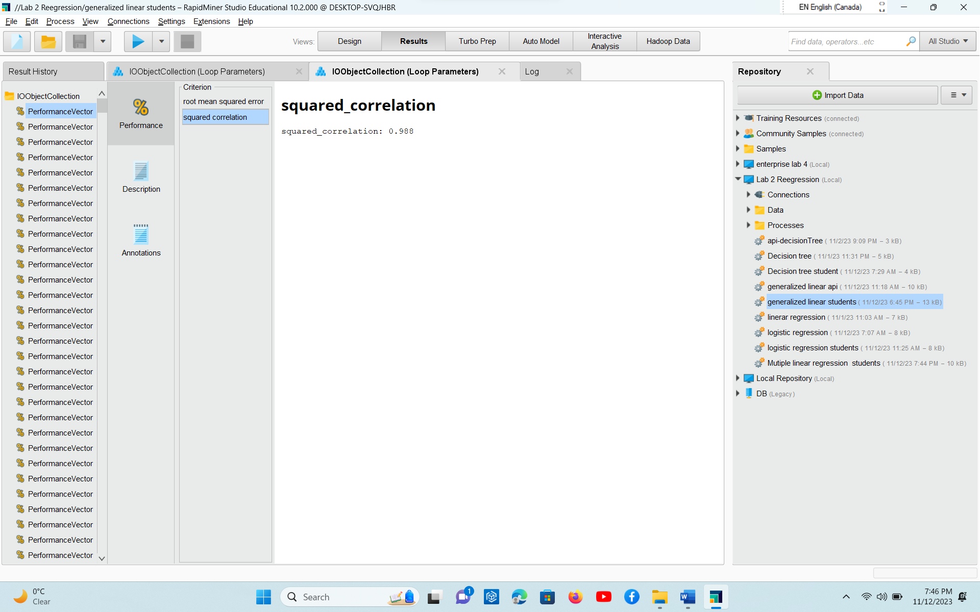

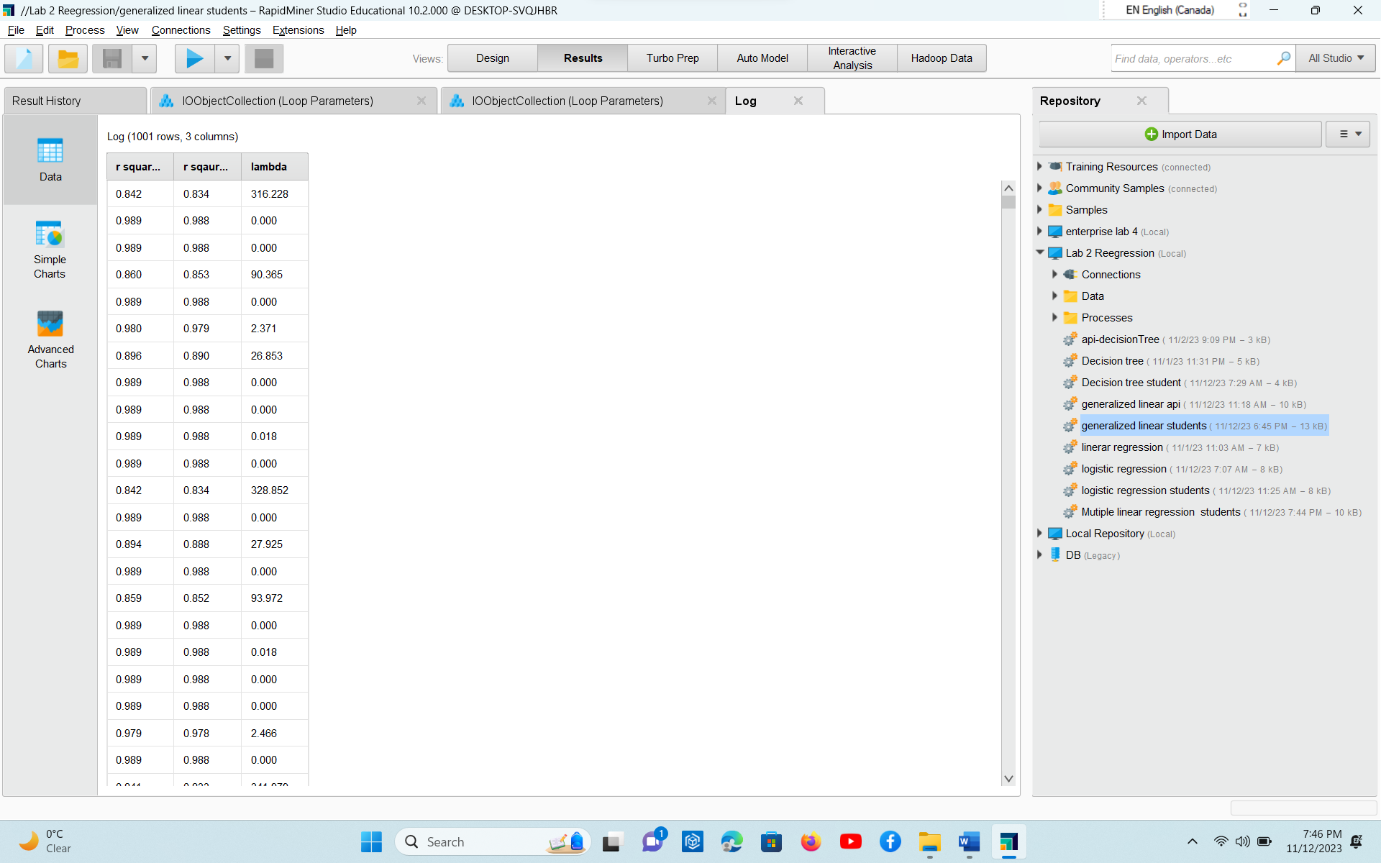

* Analysis part written in word with explaining the working and why you choose the given dataset.

I chose this dataset because it contains the attributes according to my requirement of the regression model. It has one dependent and 4 independent variables. I can do linear regression , multiple linear regression and Generalized linear regression model very easily .

* Explanation on the various operators / steps used within the process

Read CSV

Operator that reads from given csv format file.

Select attributes

It select a subset of from given file

Set role

It change the role of the attributes

Loop parameters

It iterates over a subprocess of defined parameters.

Split data

It divide the data into a subset of desired number.

Generalized Linear Model

It executes GLM algorithm by using H2O 3.30.0.1

Multiply

It creates the copies of rapid miner object

Apply model

Applies a model on example set

Performance

This operator performs statistical performance evaluation of regressions tasks and delivers a list of performance values of regression task

PART 2: Draft a decision tree modeling - 30 points

* Design Process completed for each PART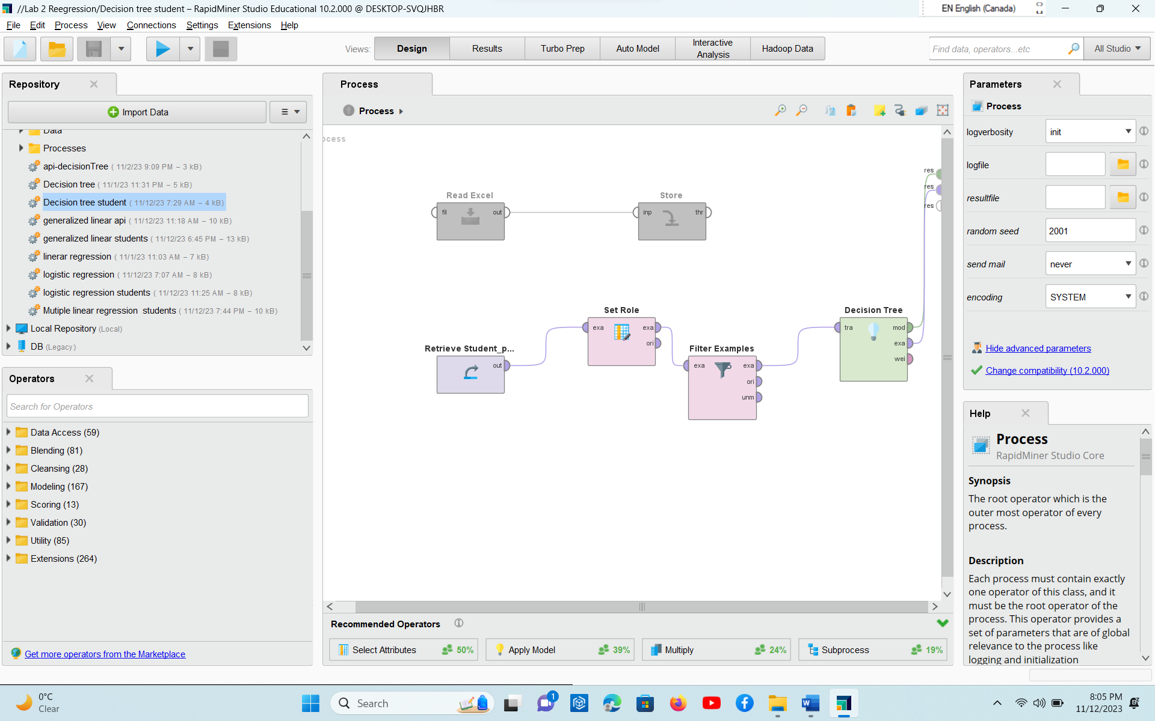
* Running Output/Results from RapidMiner (or any other tools/ languages) 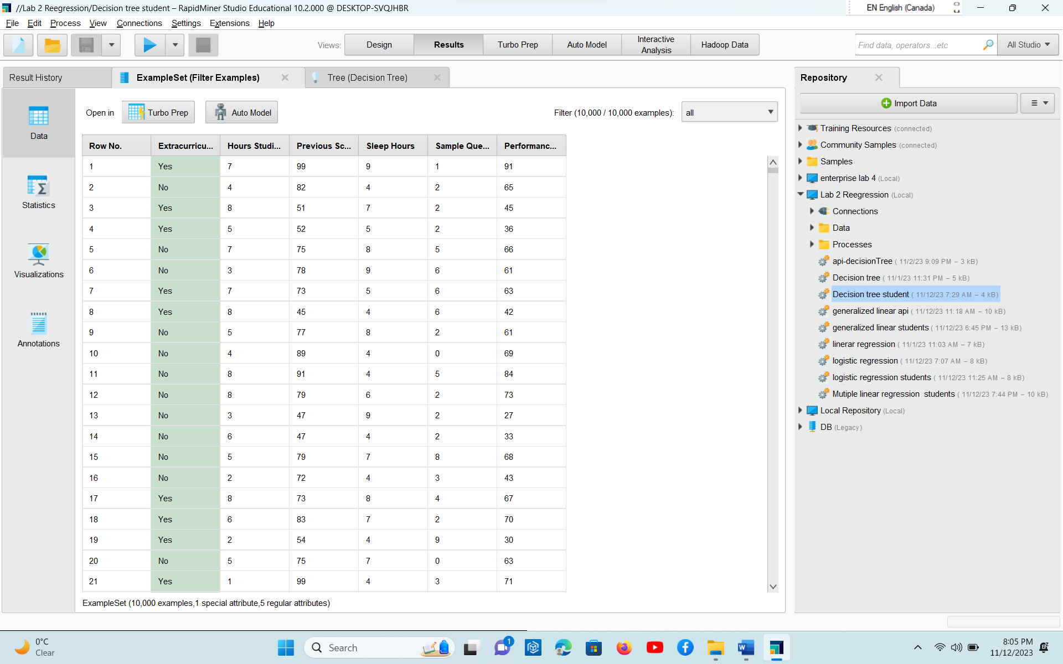
* 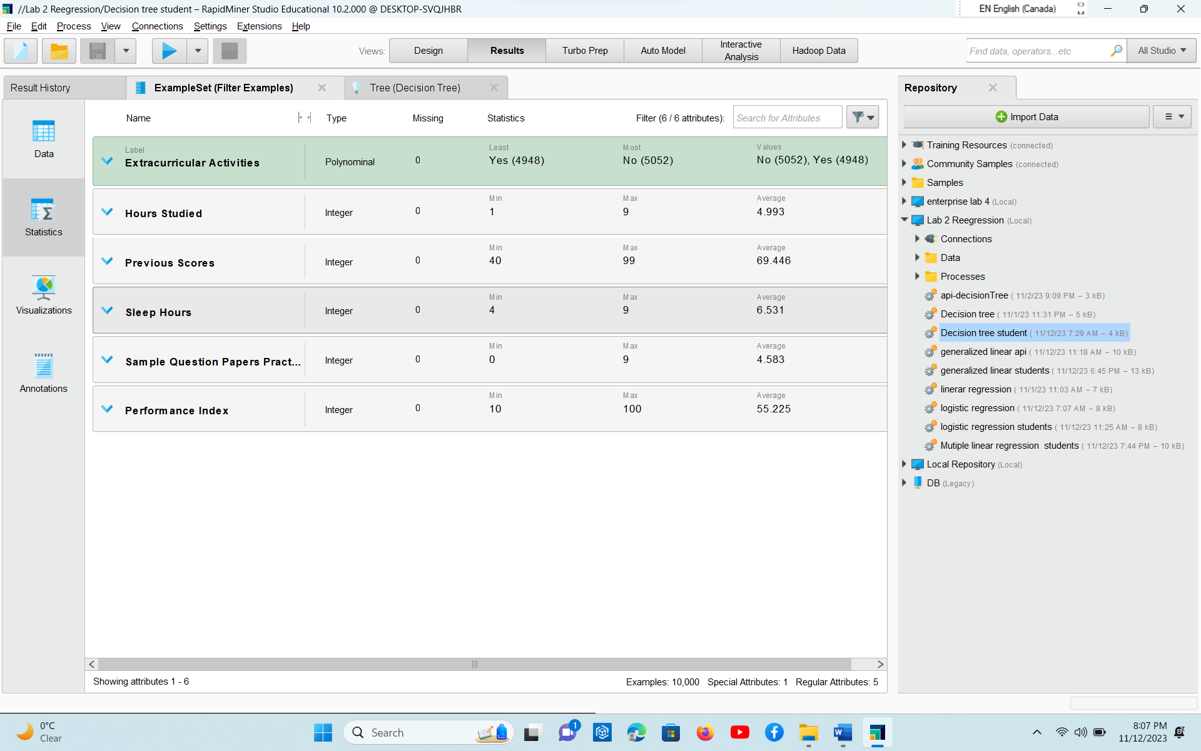
* 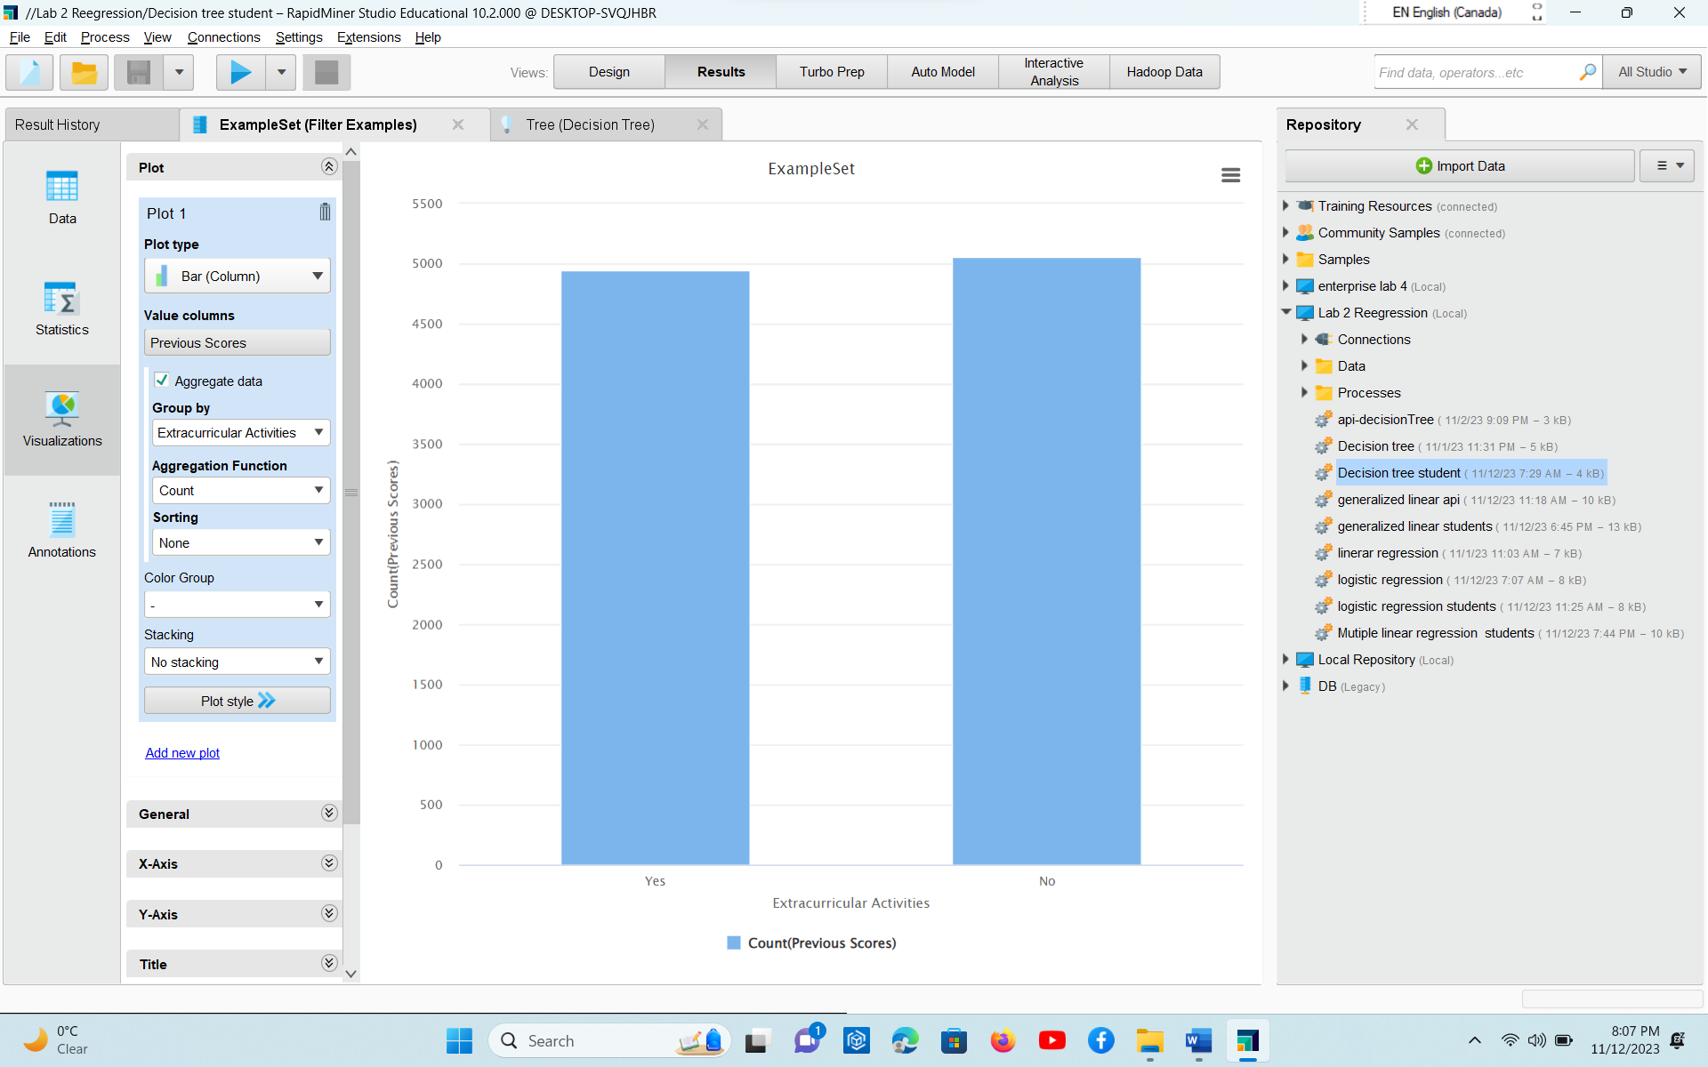
* 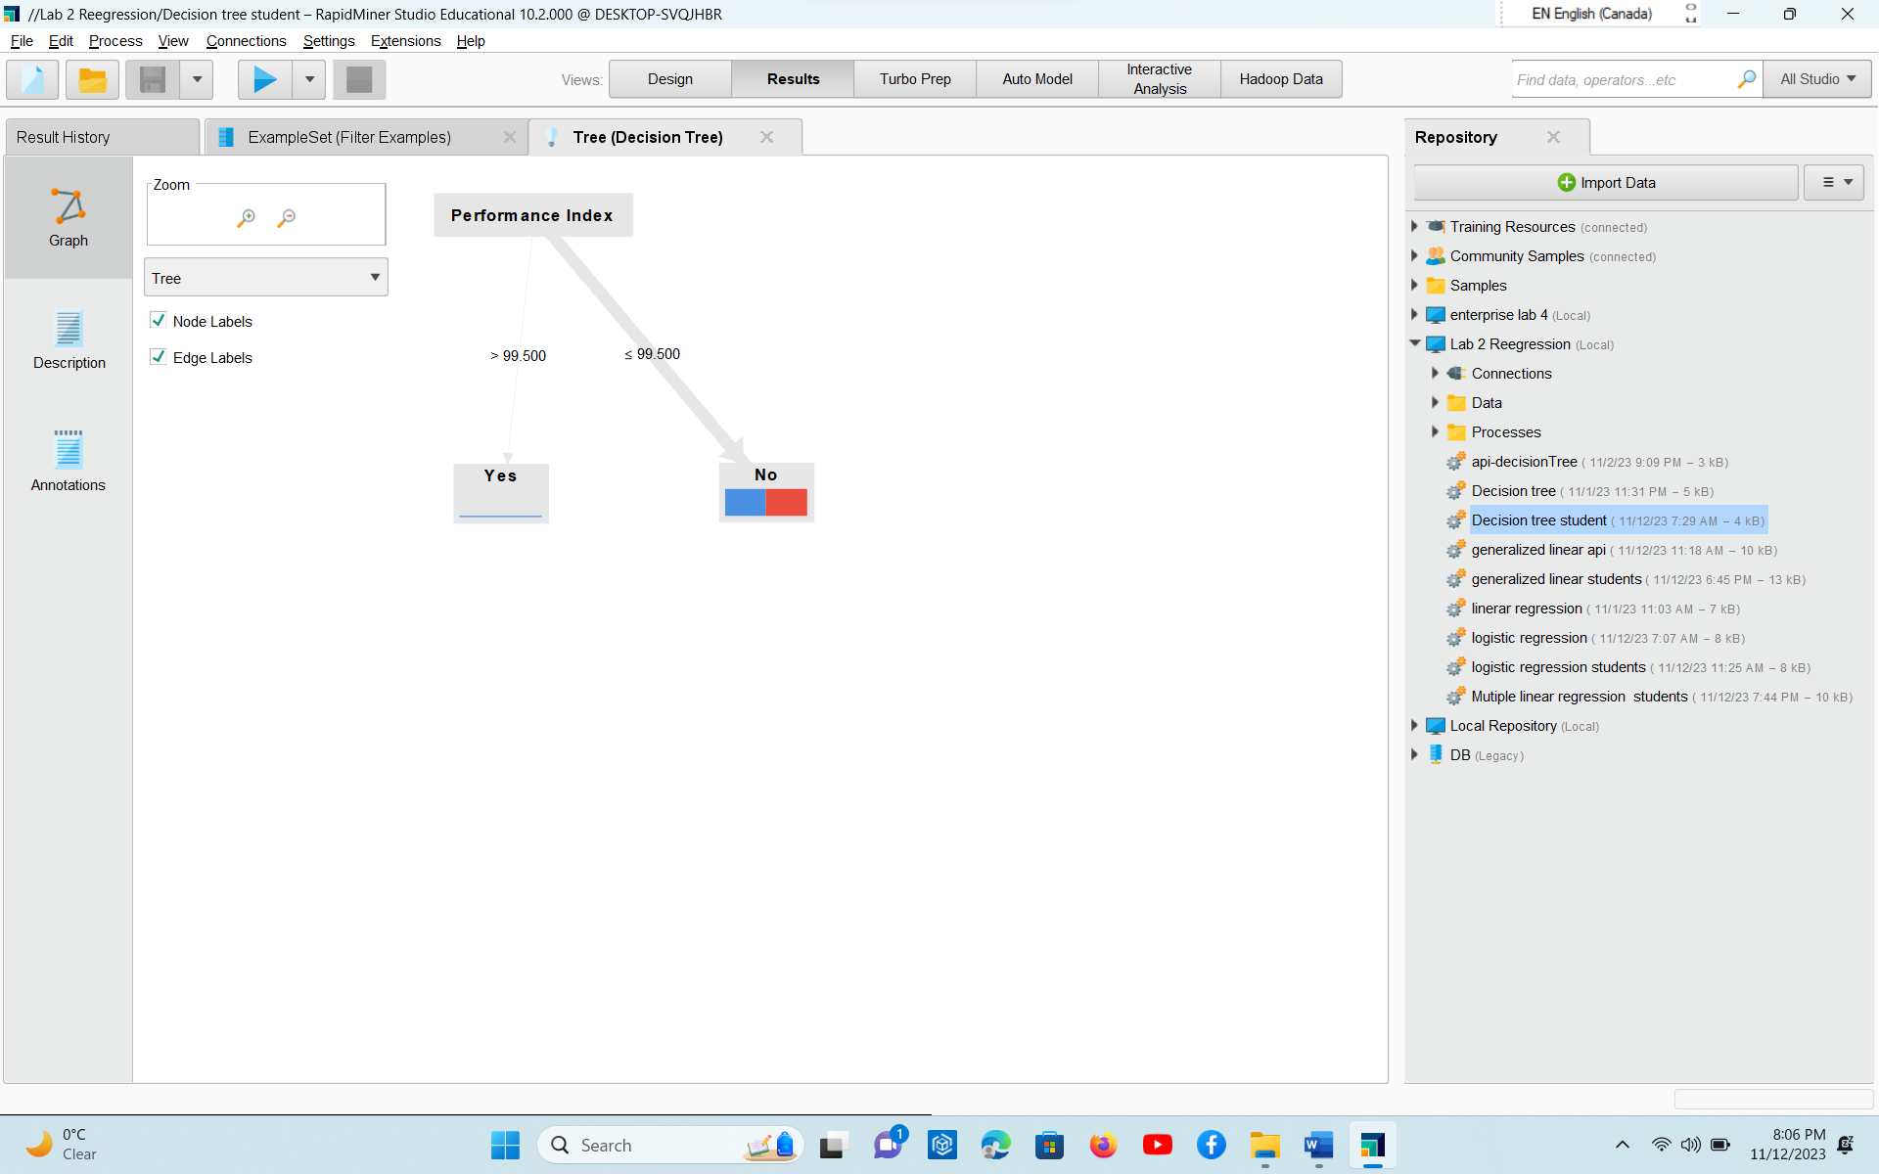
* 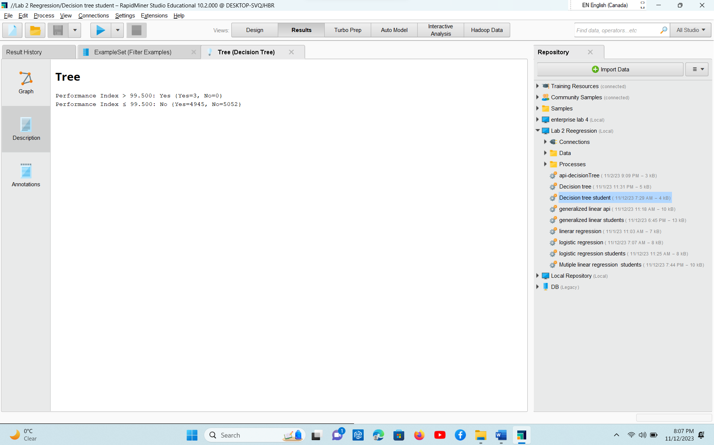
* Analysis part written in word with explaining the working and why you choose the given dataset.

I already took this dataset for other models that why I perform Decision tree model on this data as well as we are told to perform all regression models on same datasets .

I know this is not as suitable for dataset for Decision Tree regression model. I perform Decision tree on some other datasets as well.

* Explanation on the various operators / steps used within the process

Read excel

Read from excel file

Store Excel

Store as an object

Retrieve student

Take the object stored in repository and use for our requirements

Set role

Change the role of the required attribute

Filter example

It filter the example sets created by an operator and remove the others

Decision Tree

Operator generates a decision tree model which can be used for regression and classifications

I performed this decision tree model on another dataset screen shots are as above with nominal type attributes.

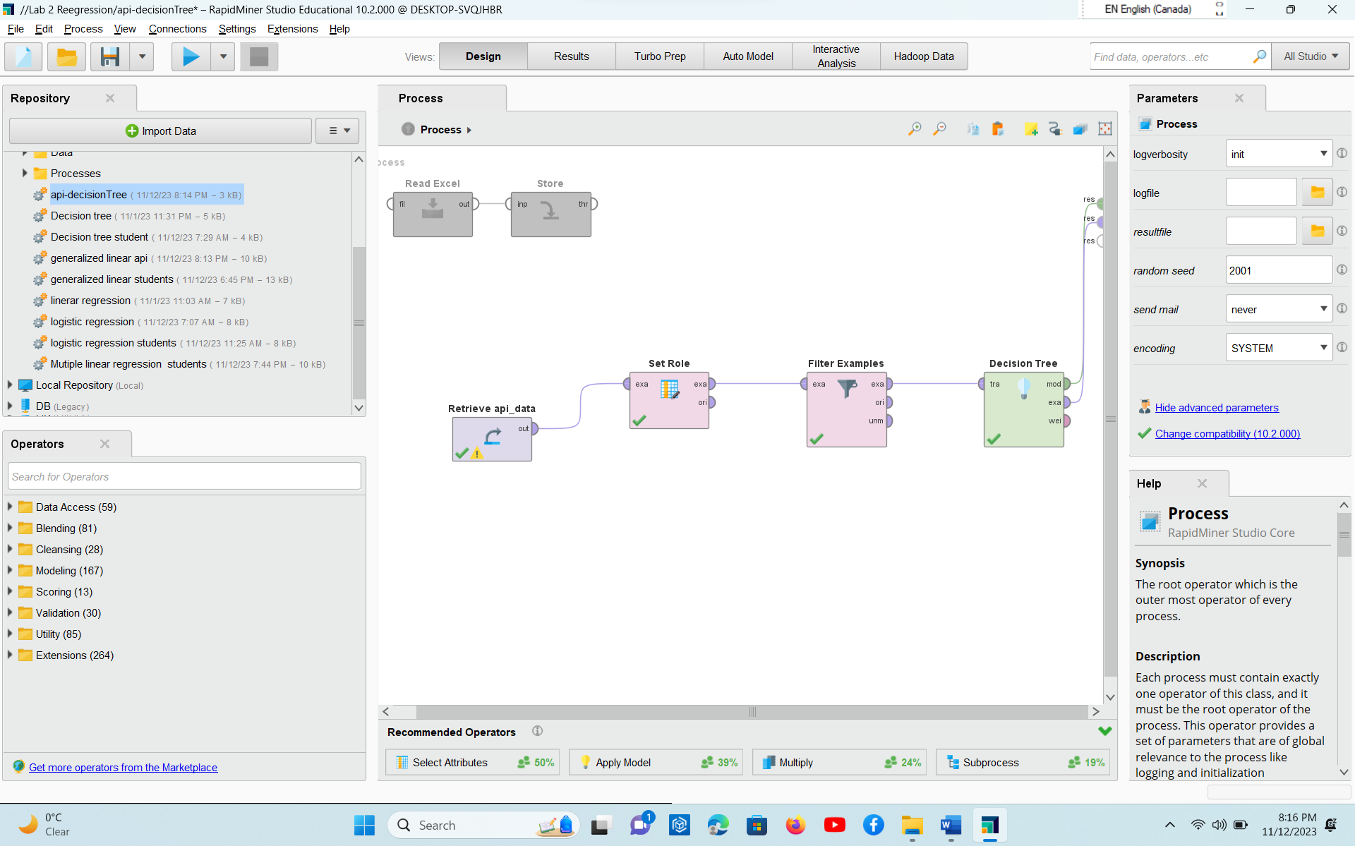

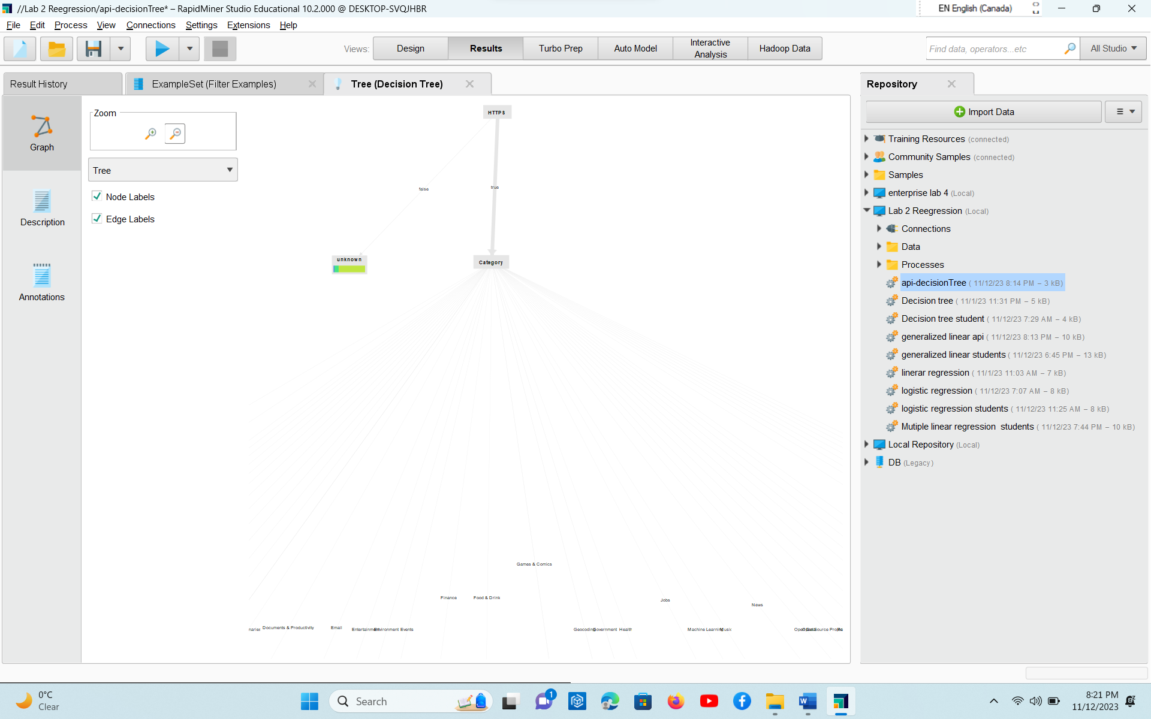

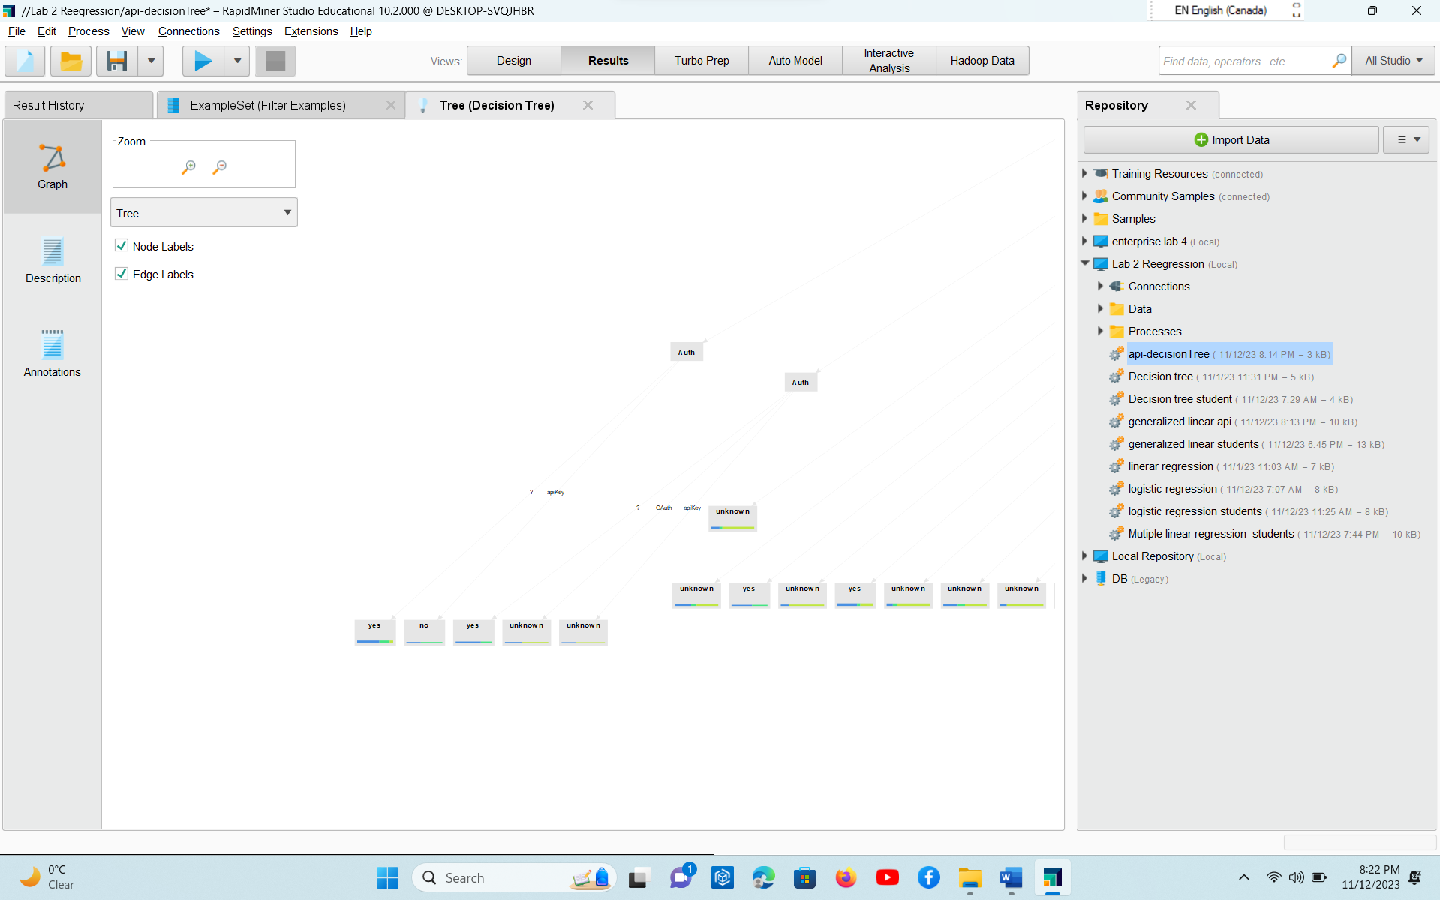

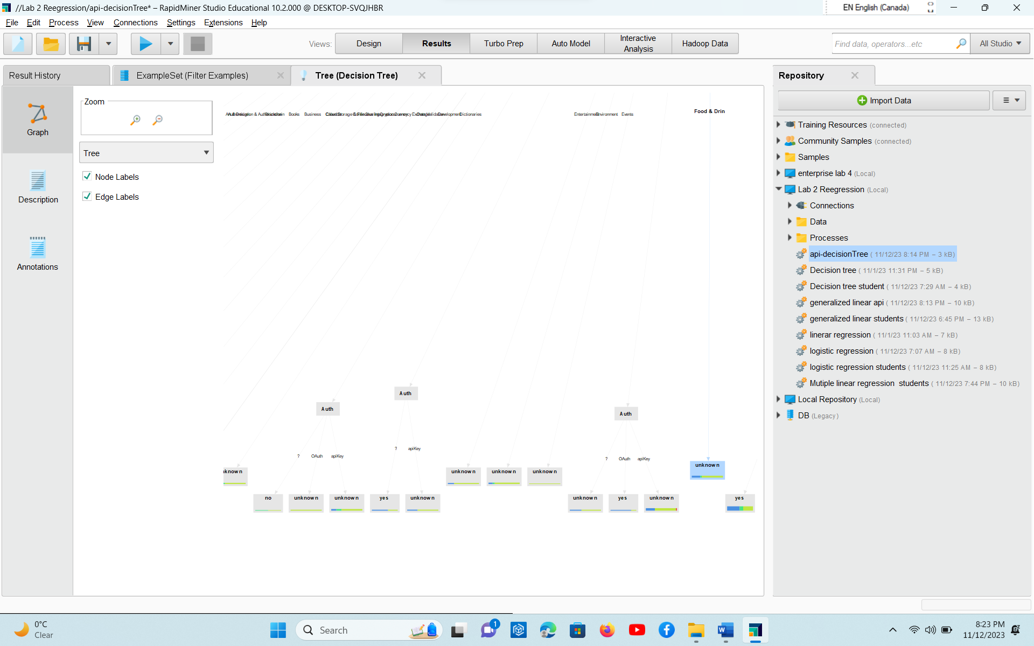

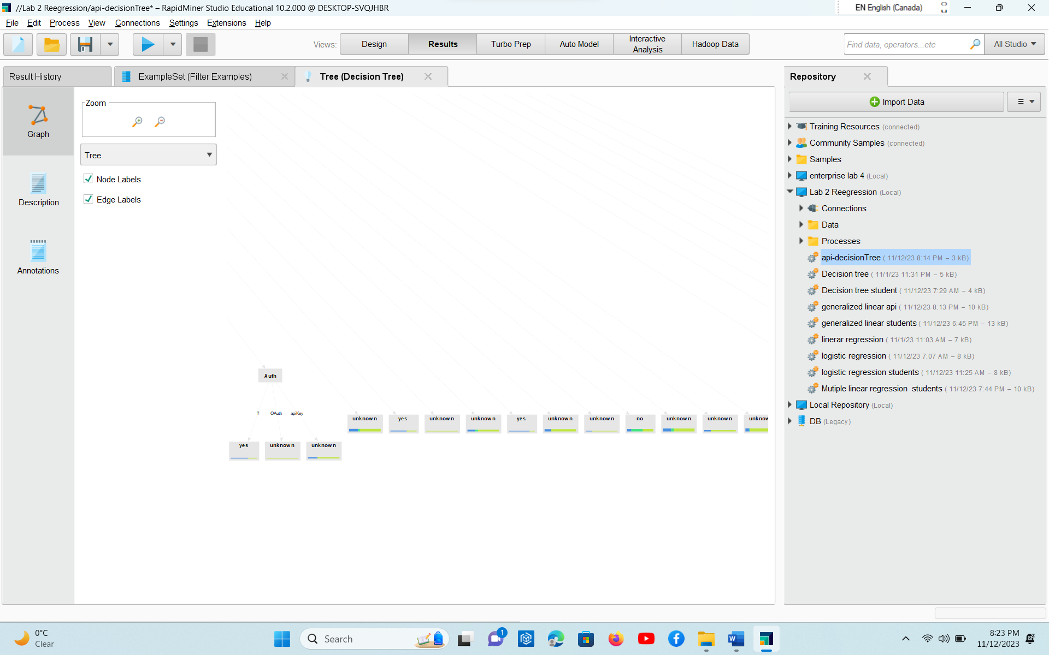

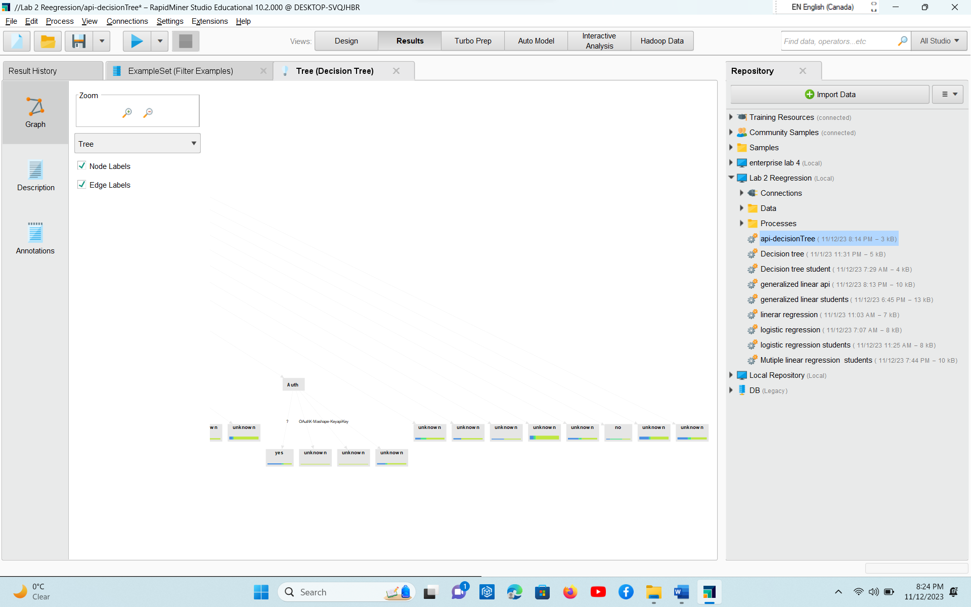

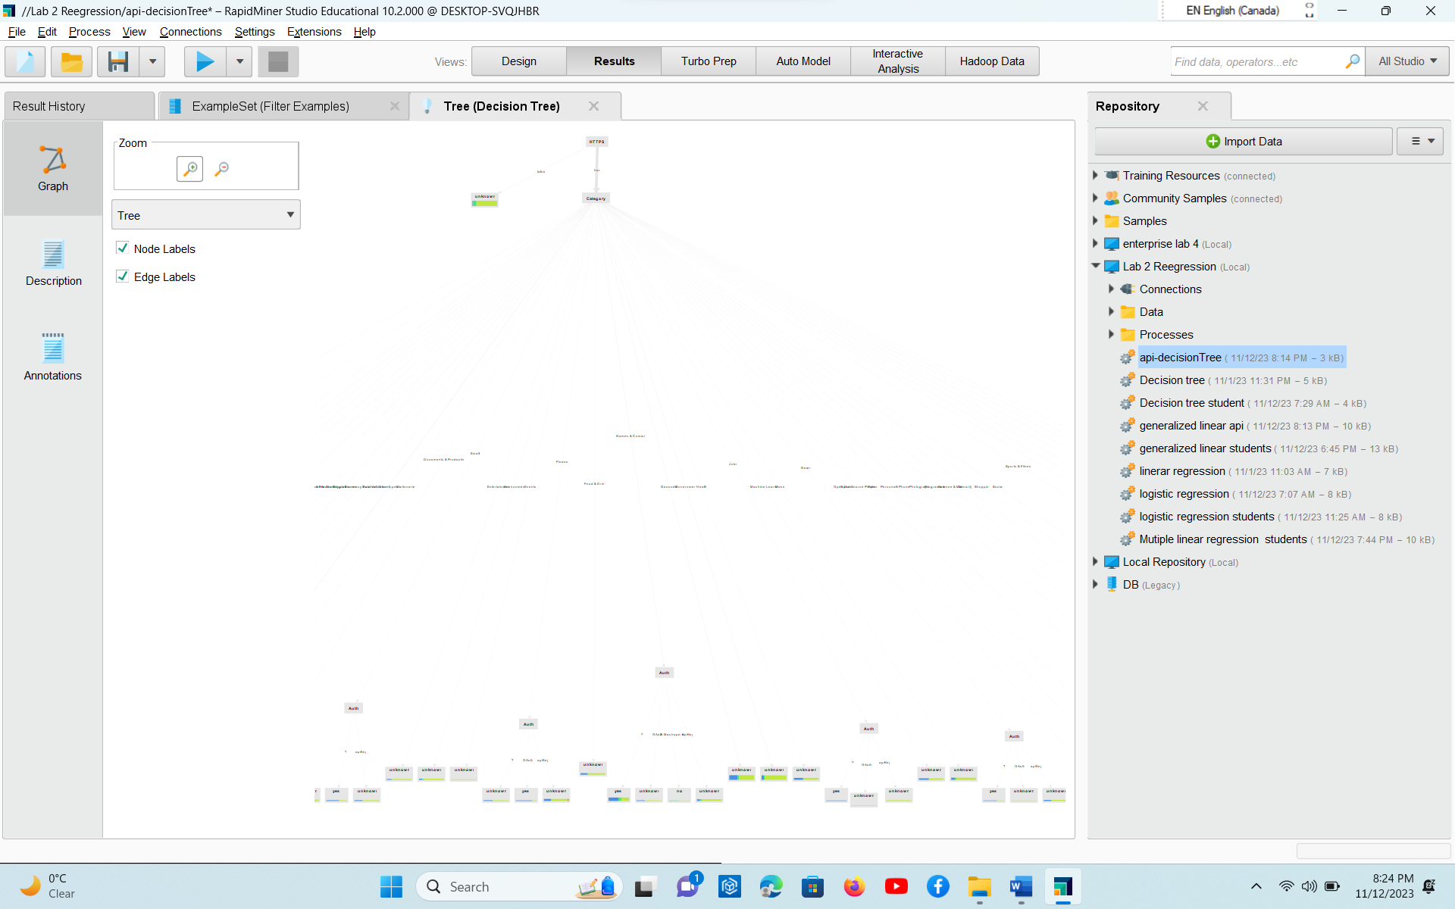

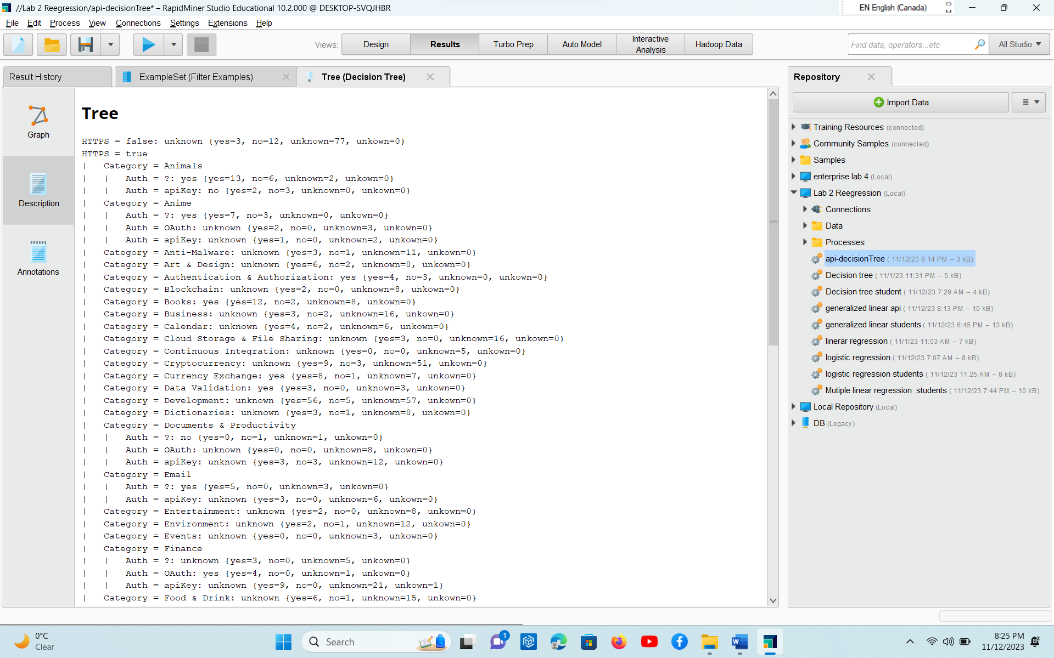

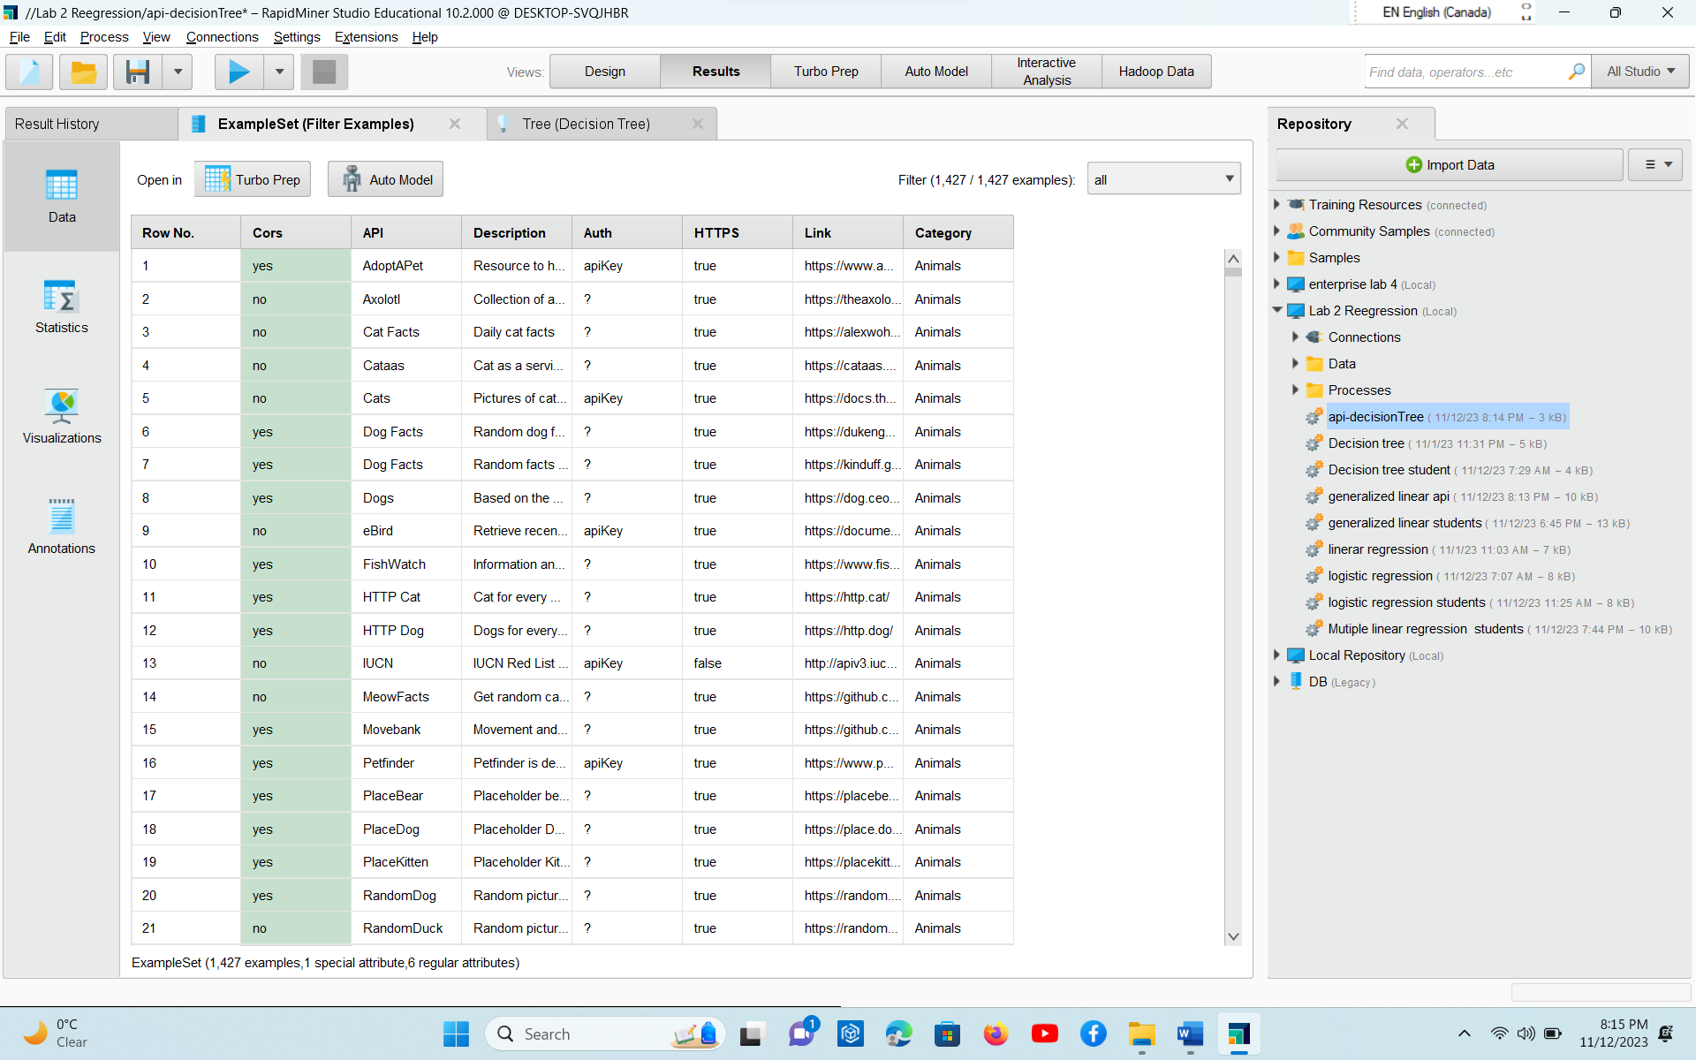

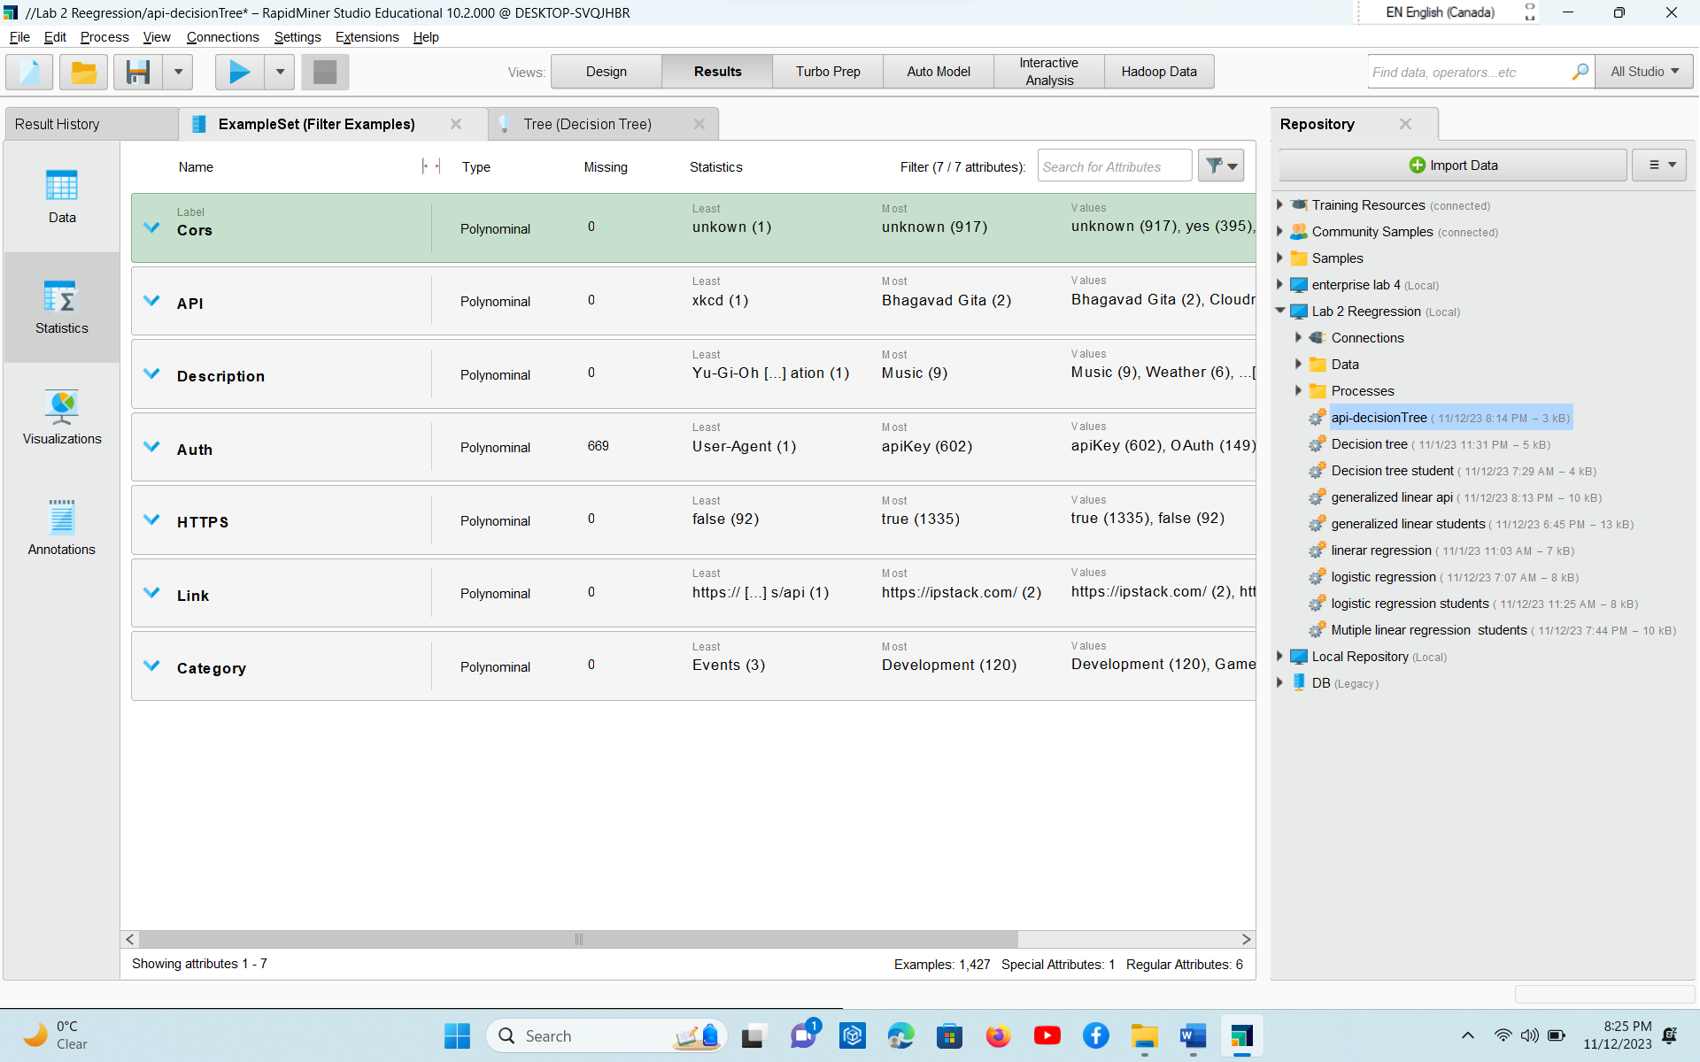

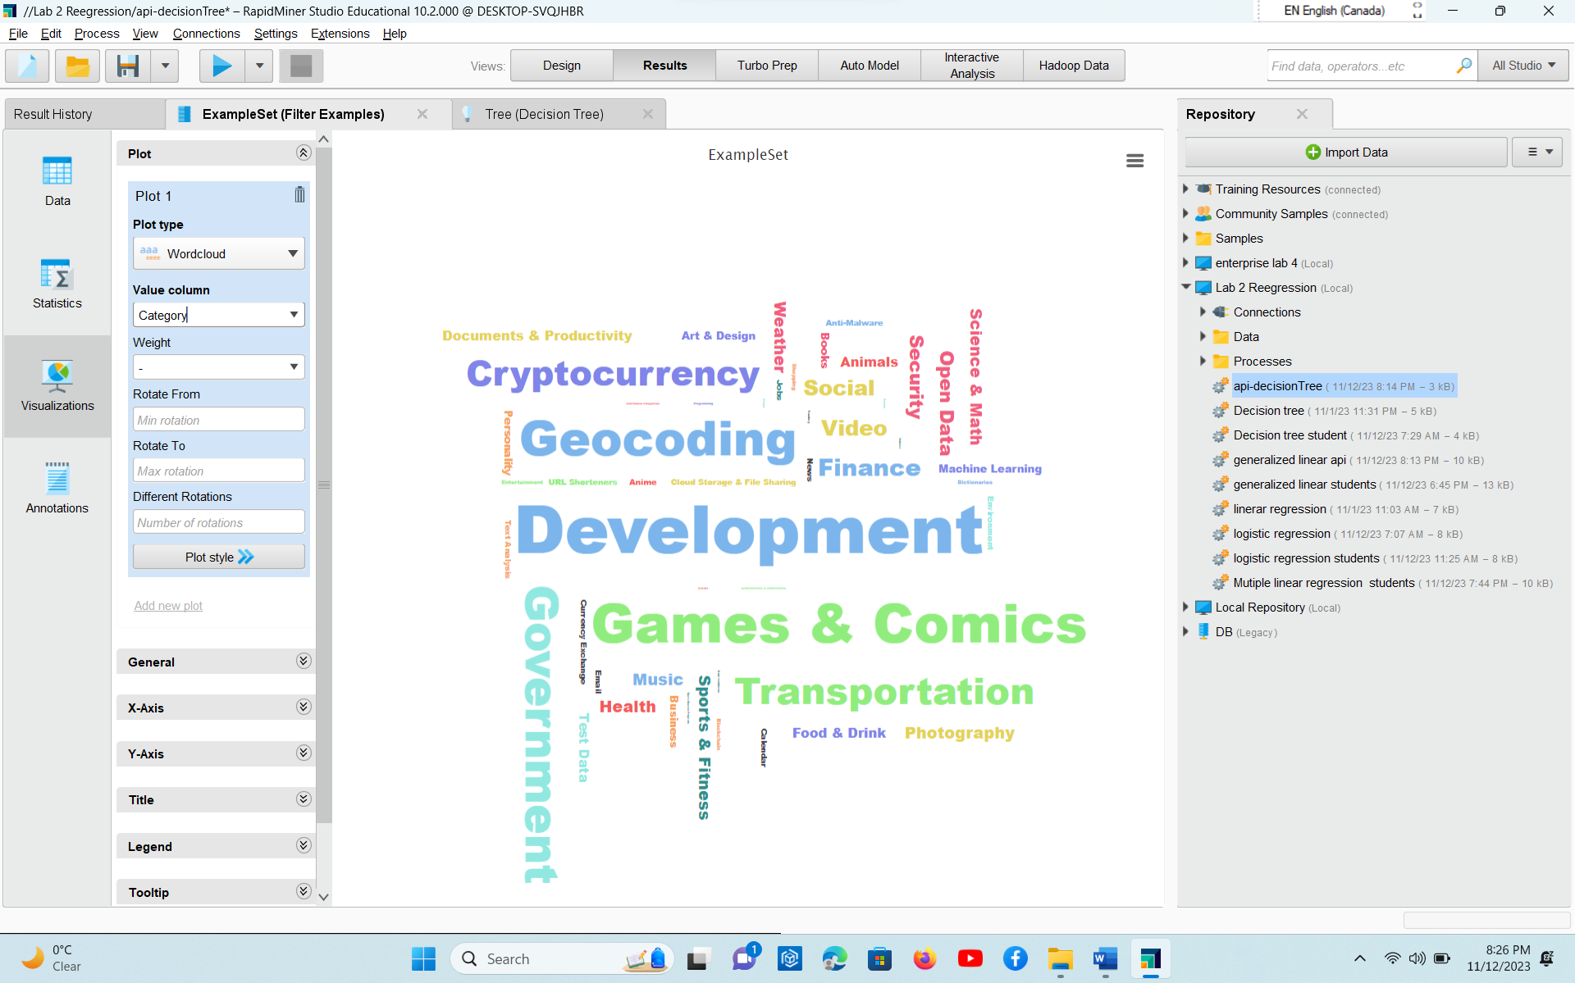

Another dataset I took for Decision tree

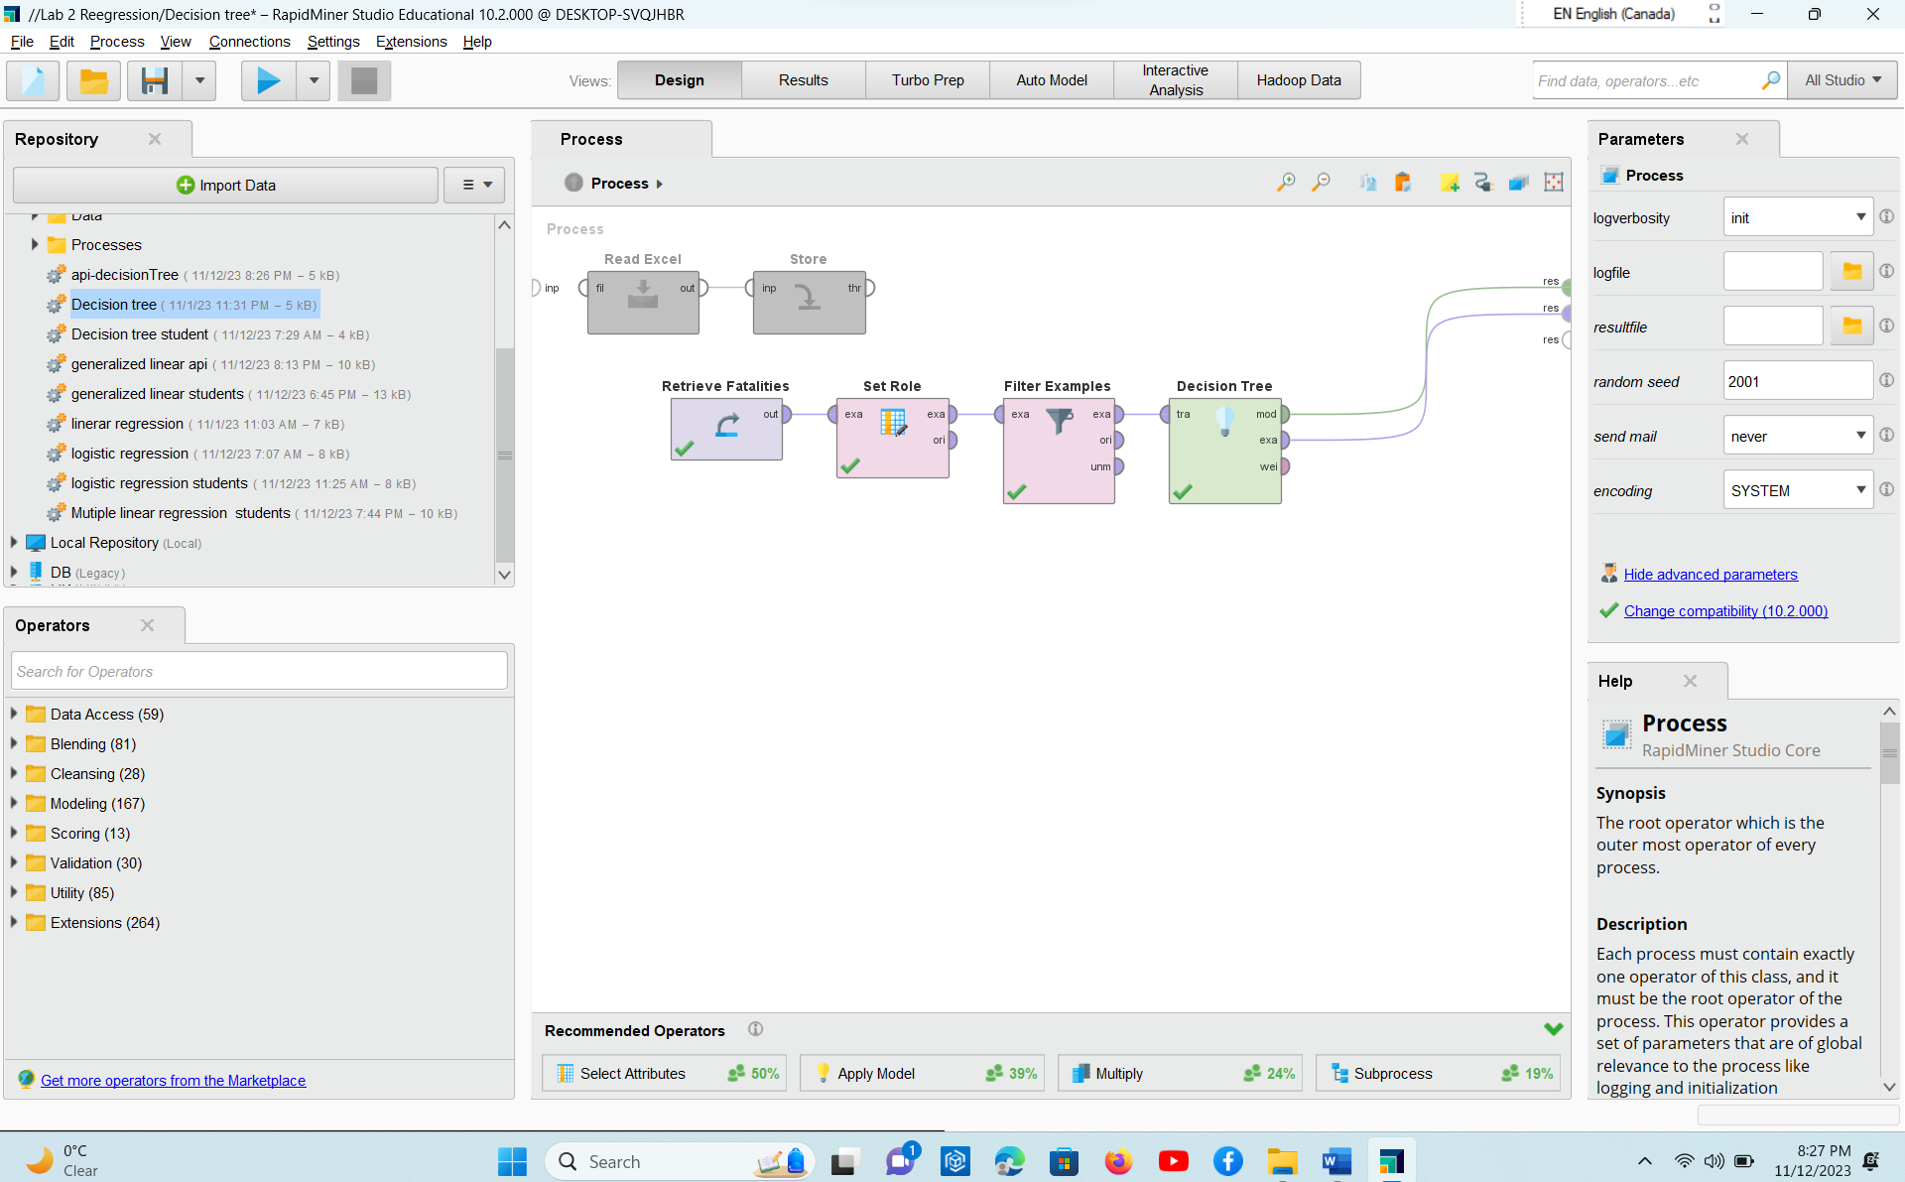

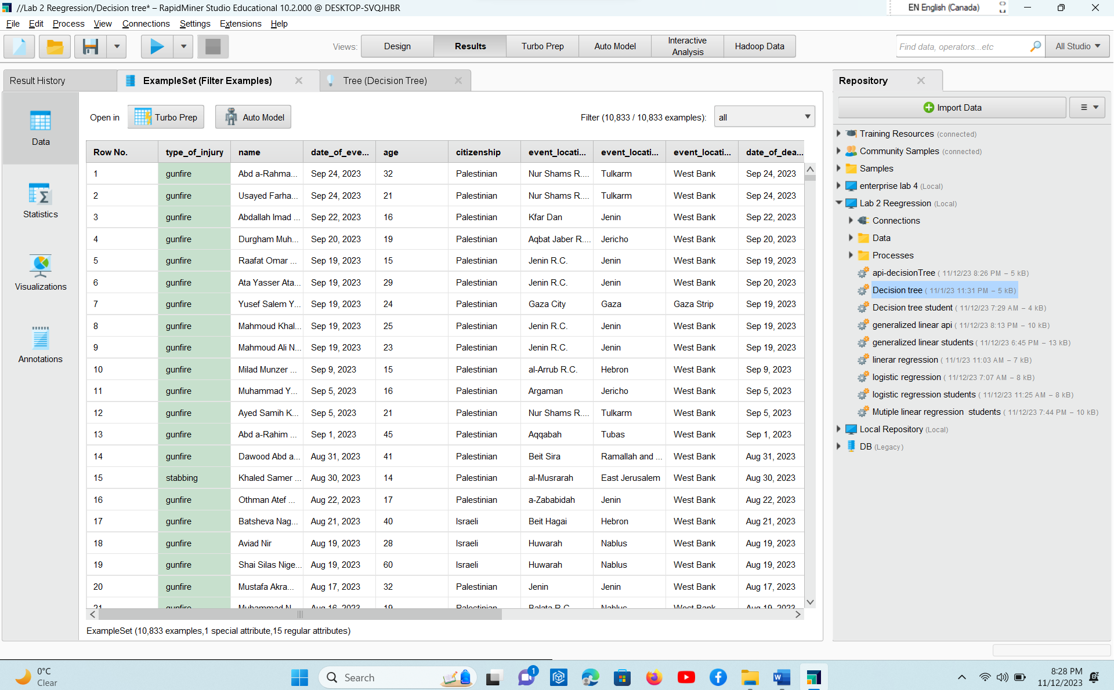

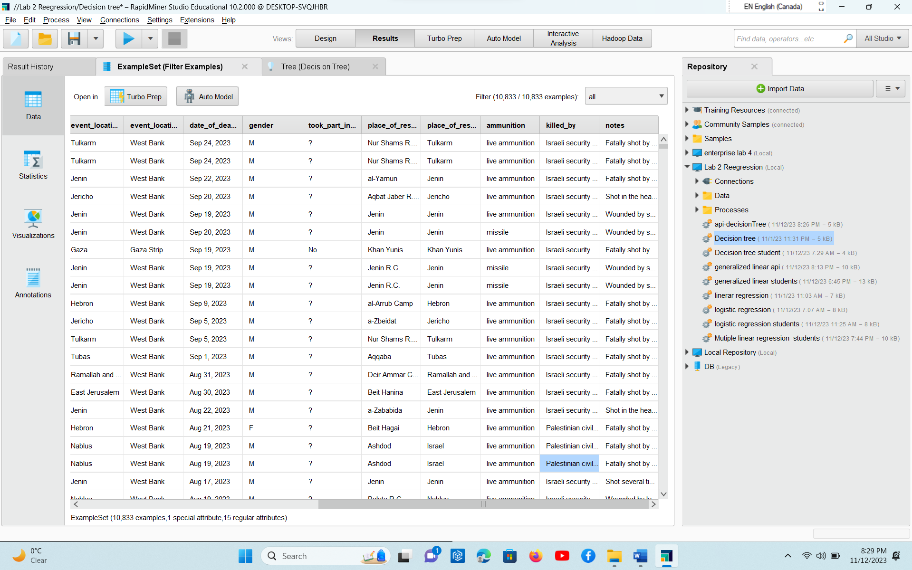

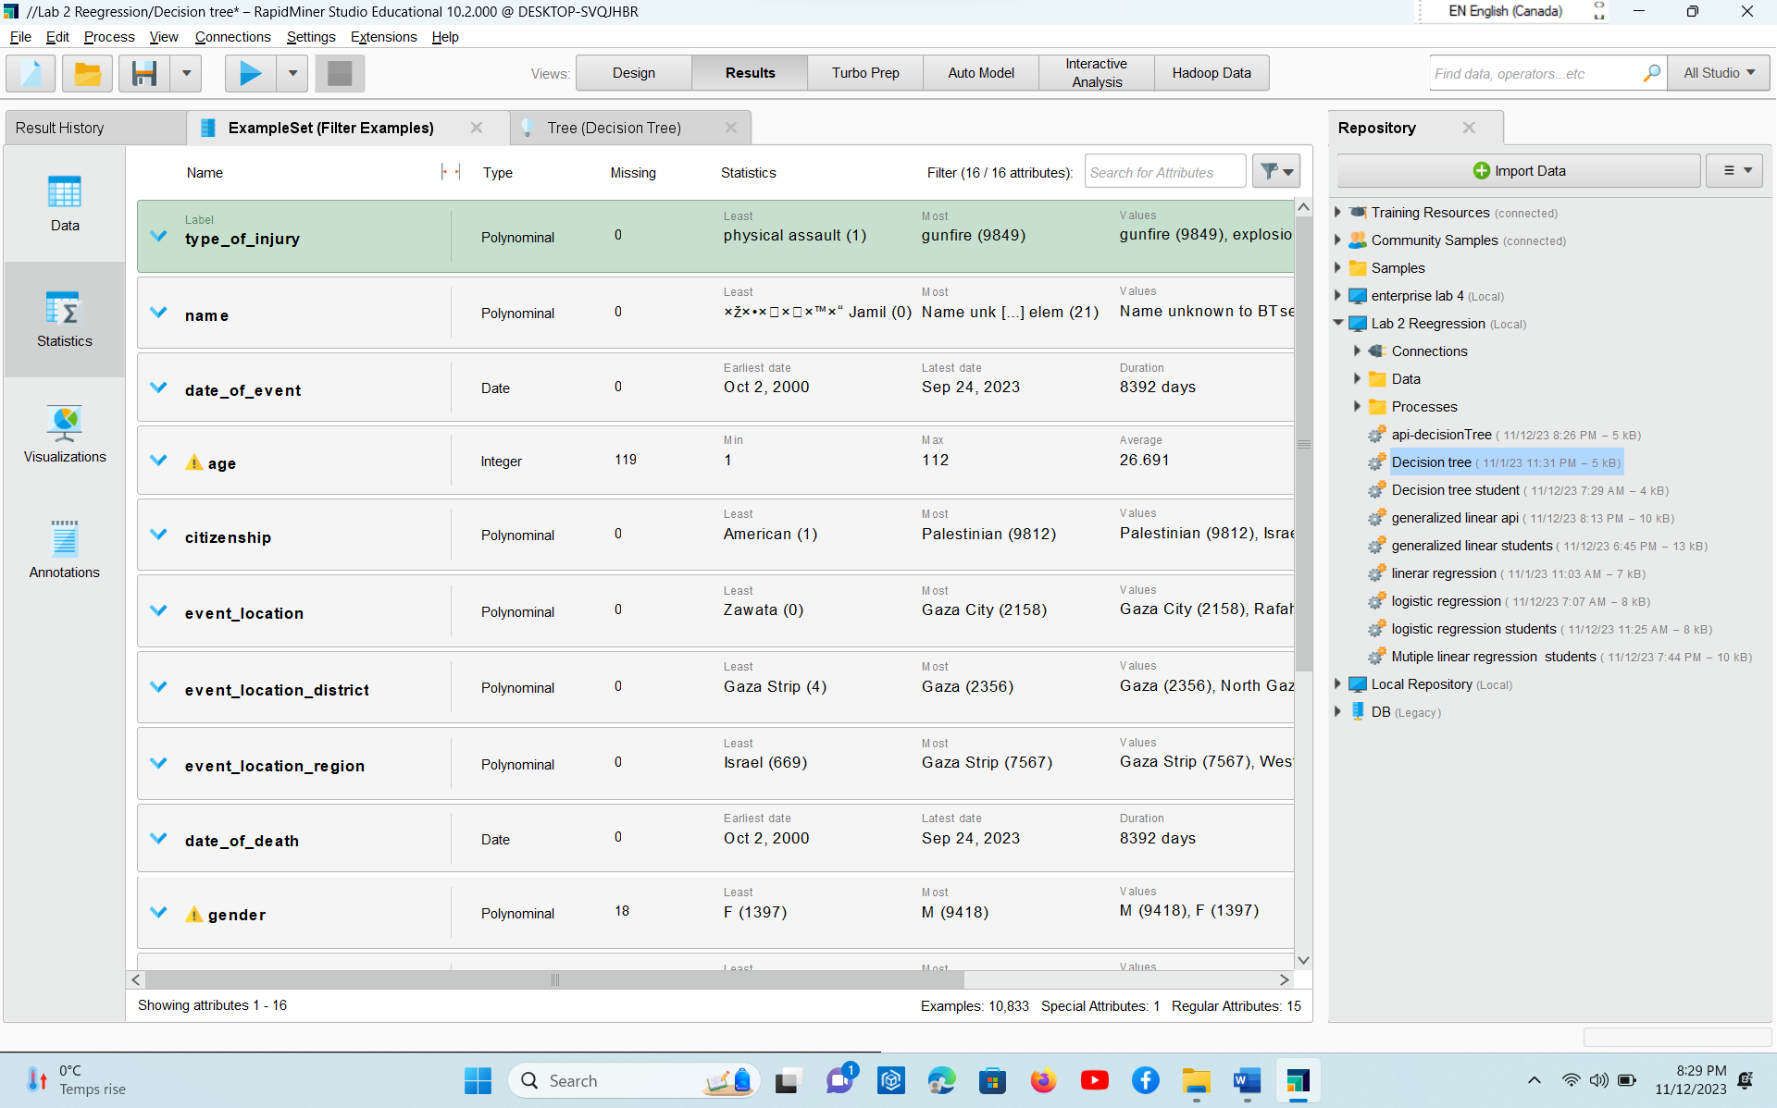

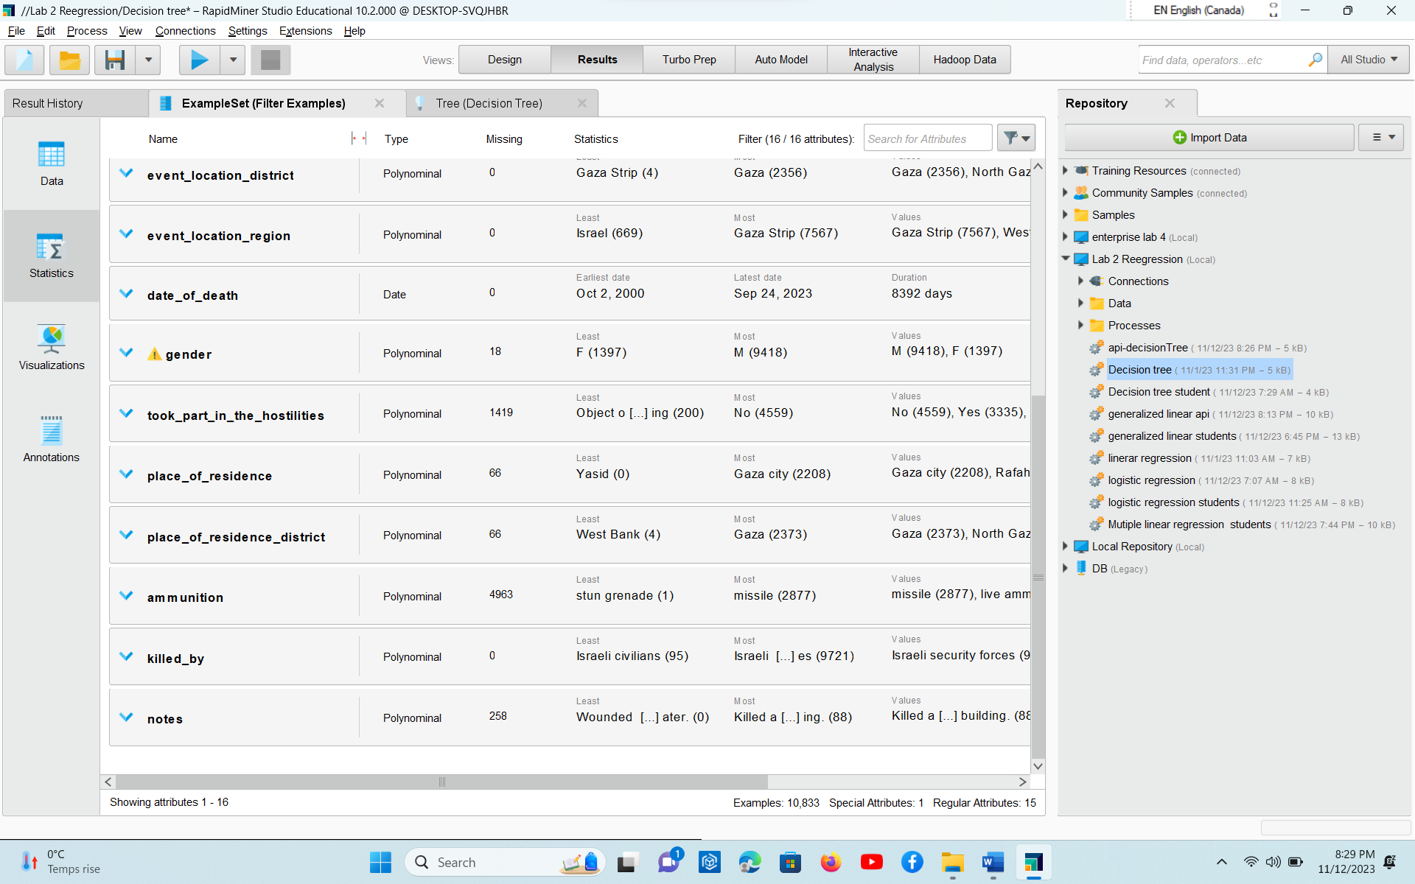

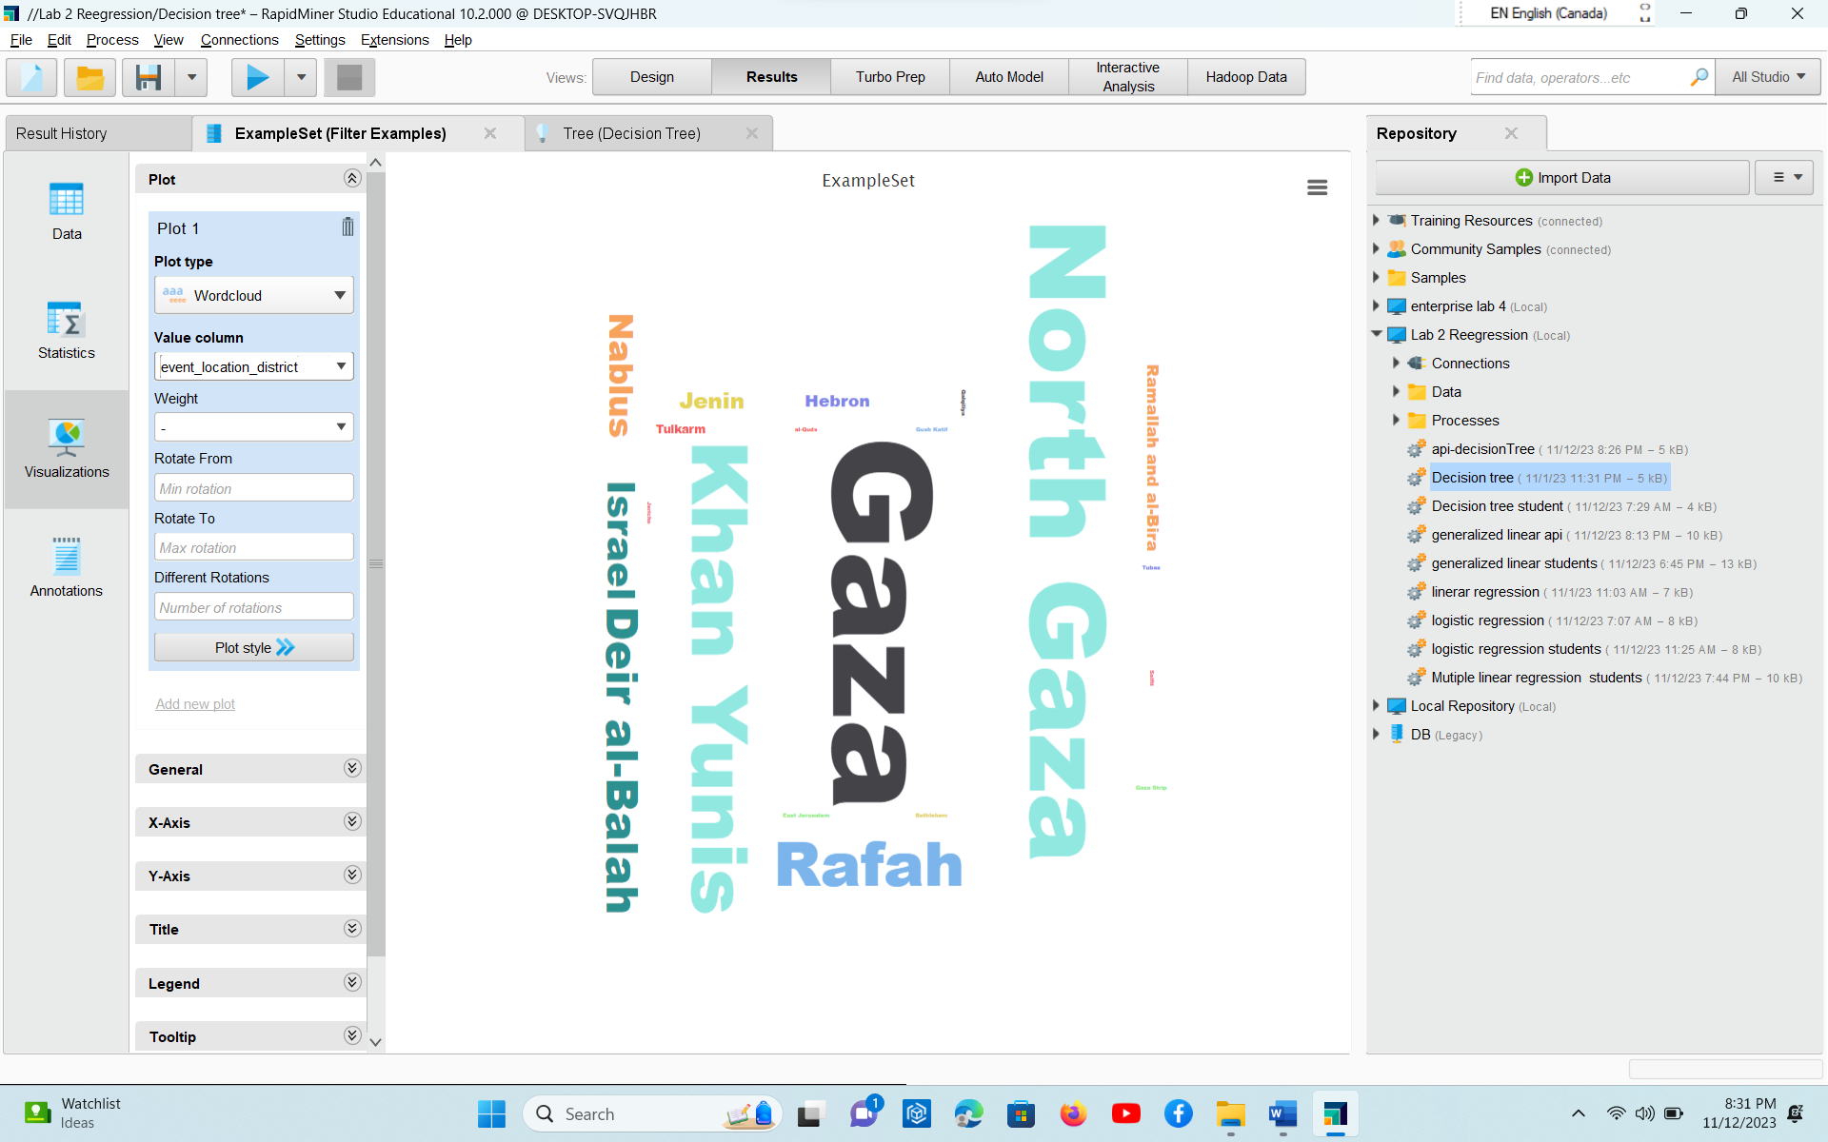

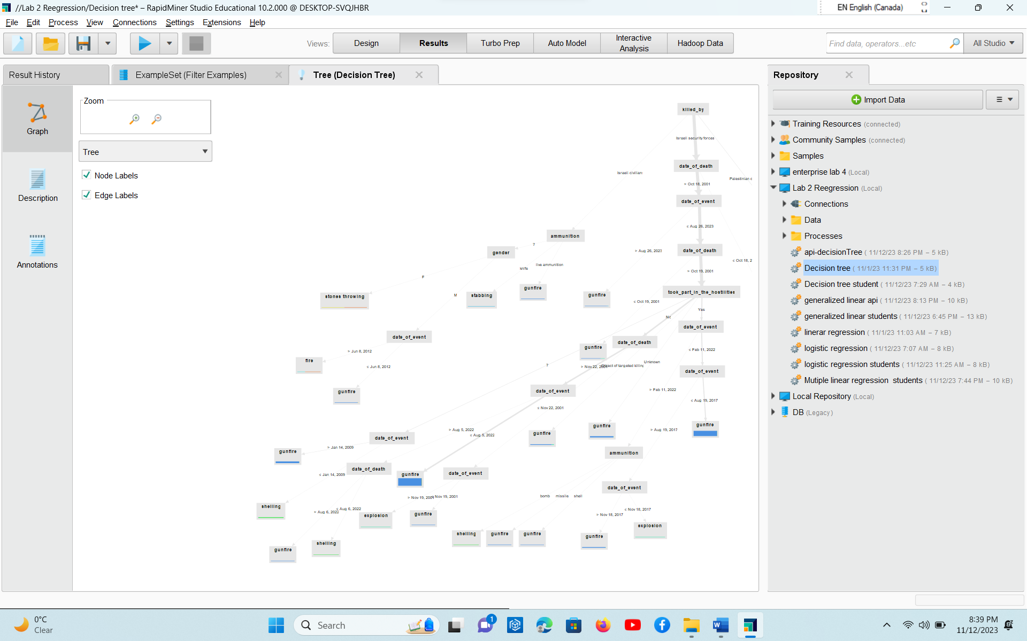

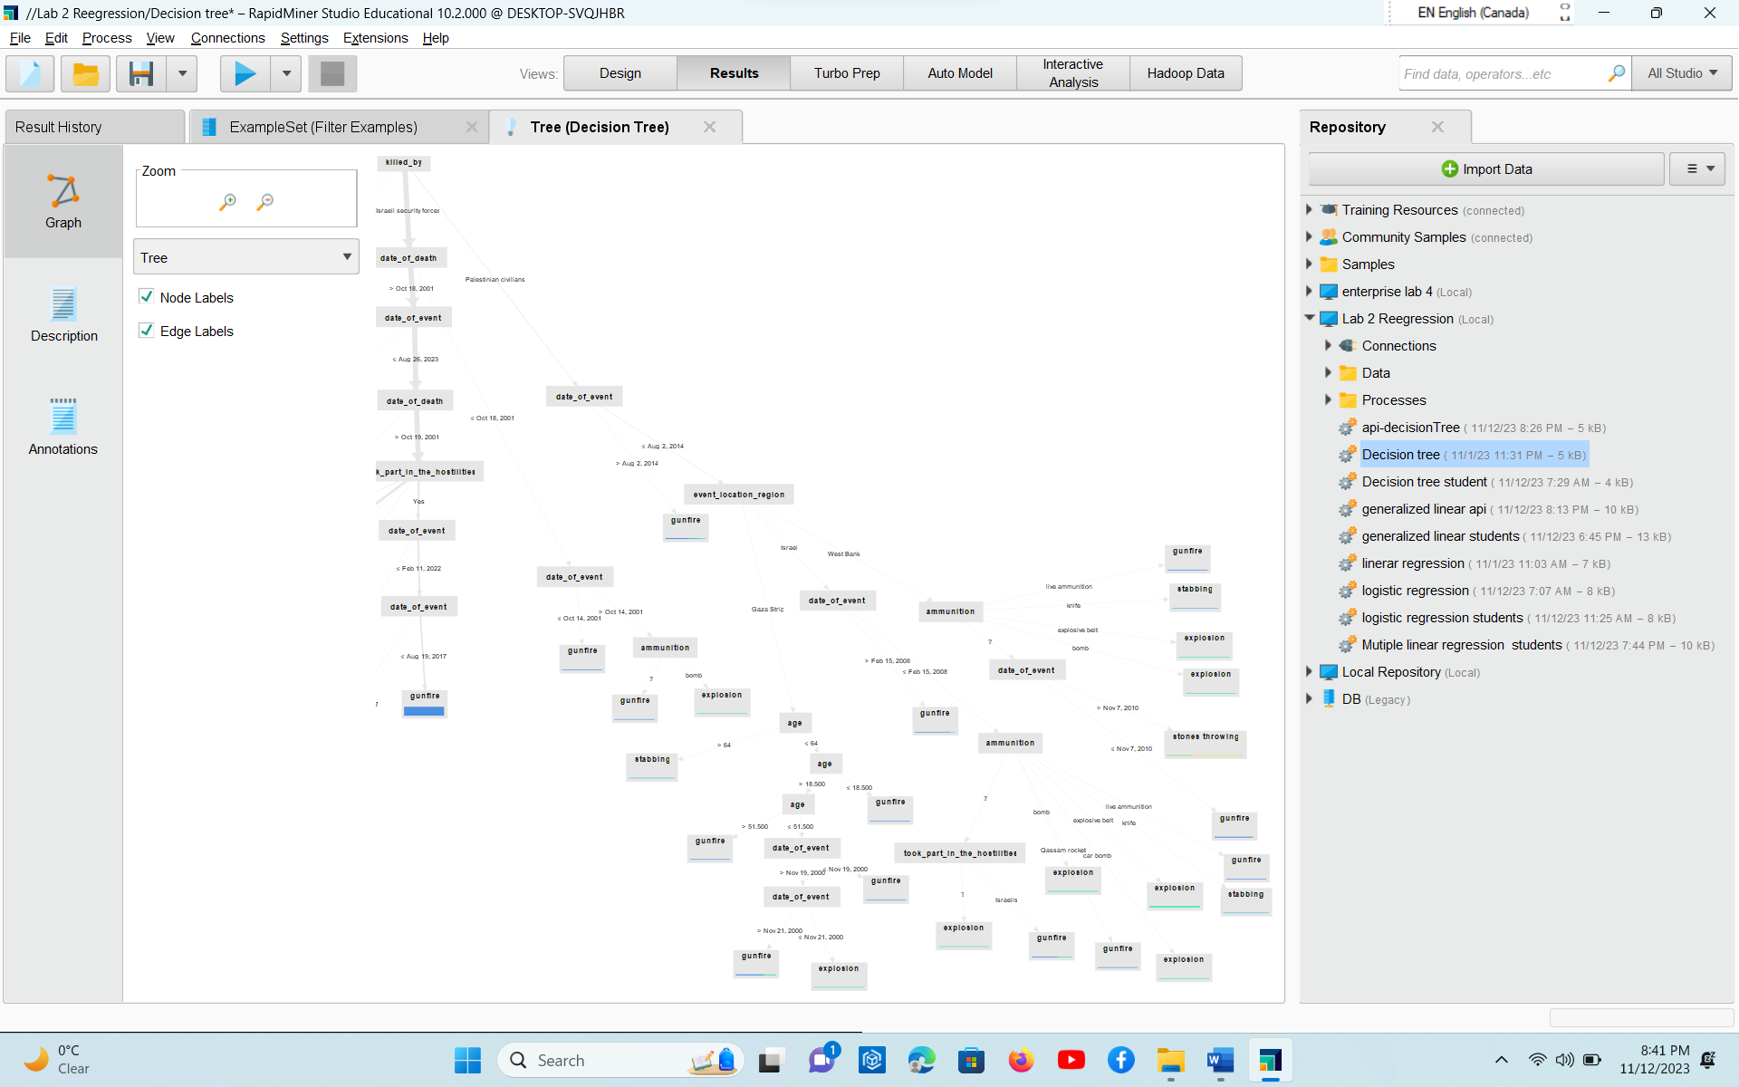

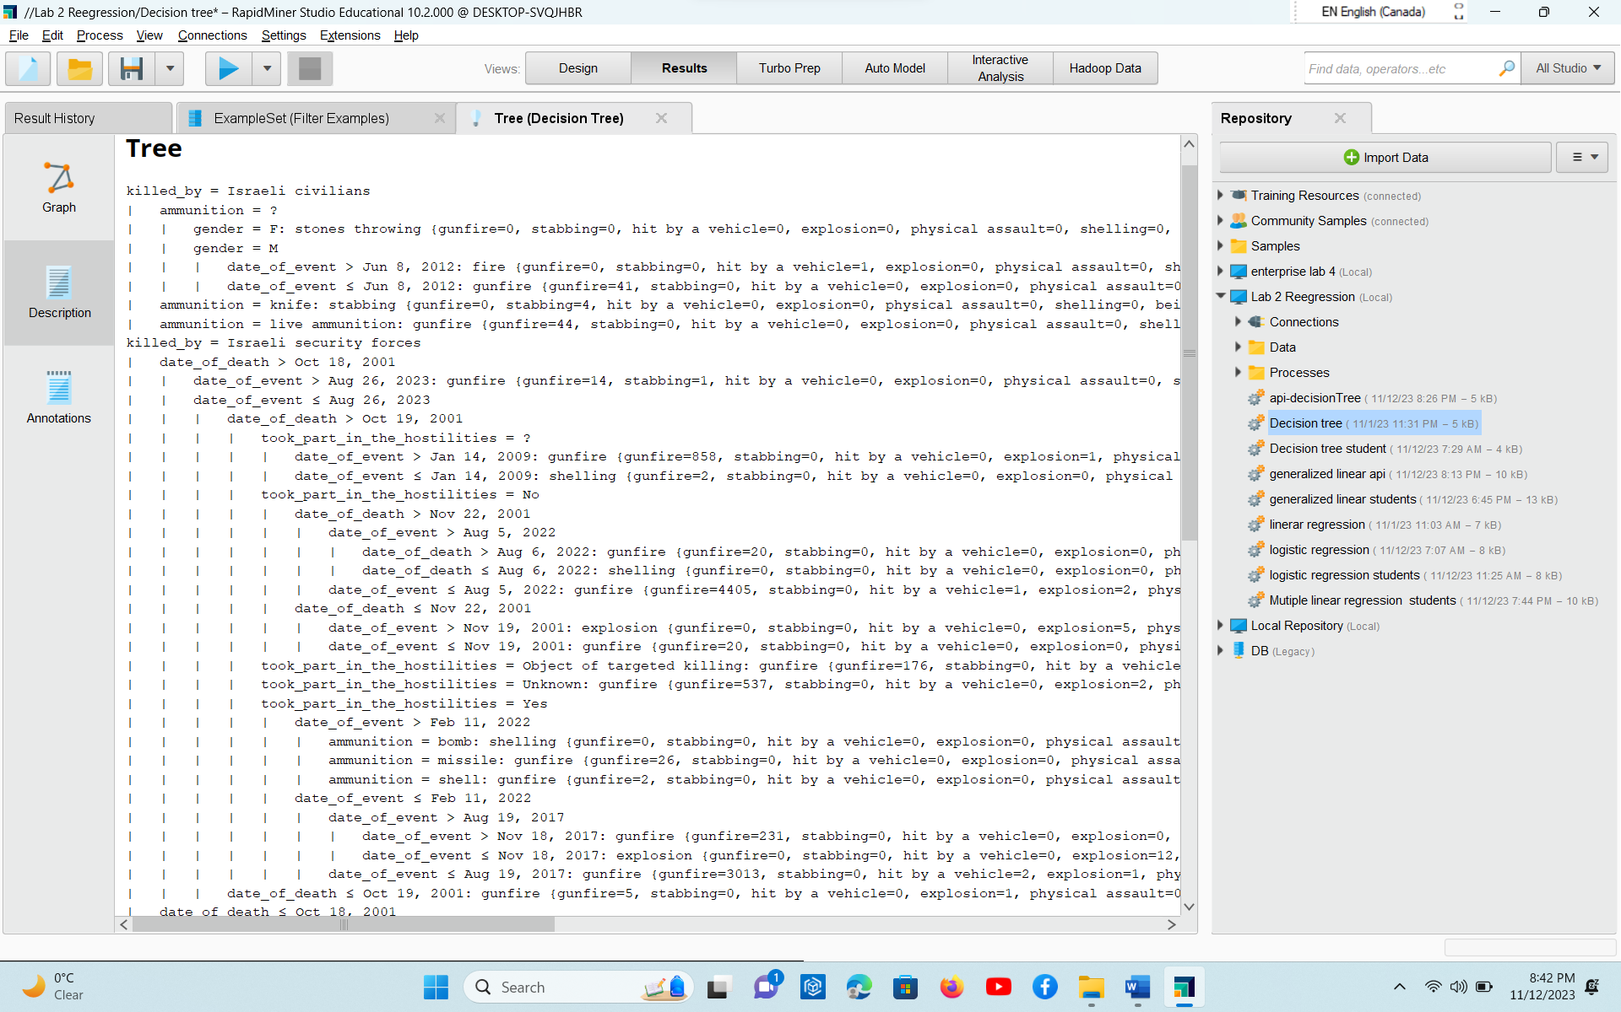

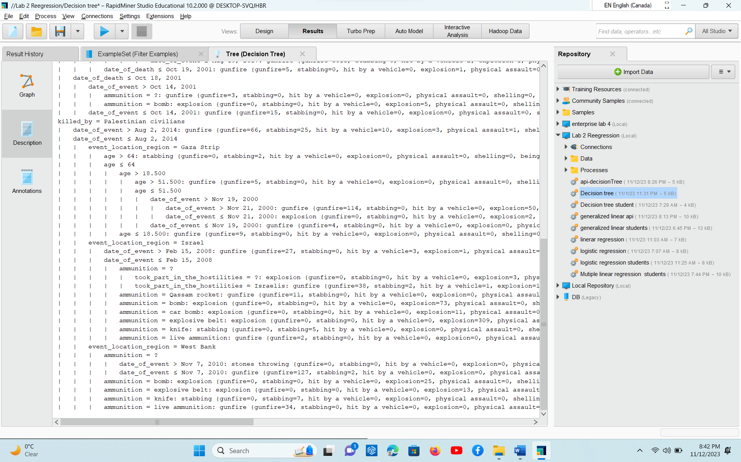

PART 3: Draft a logistic regression modeling - 30 points

* Design Process completed for each PART

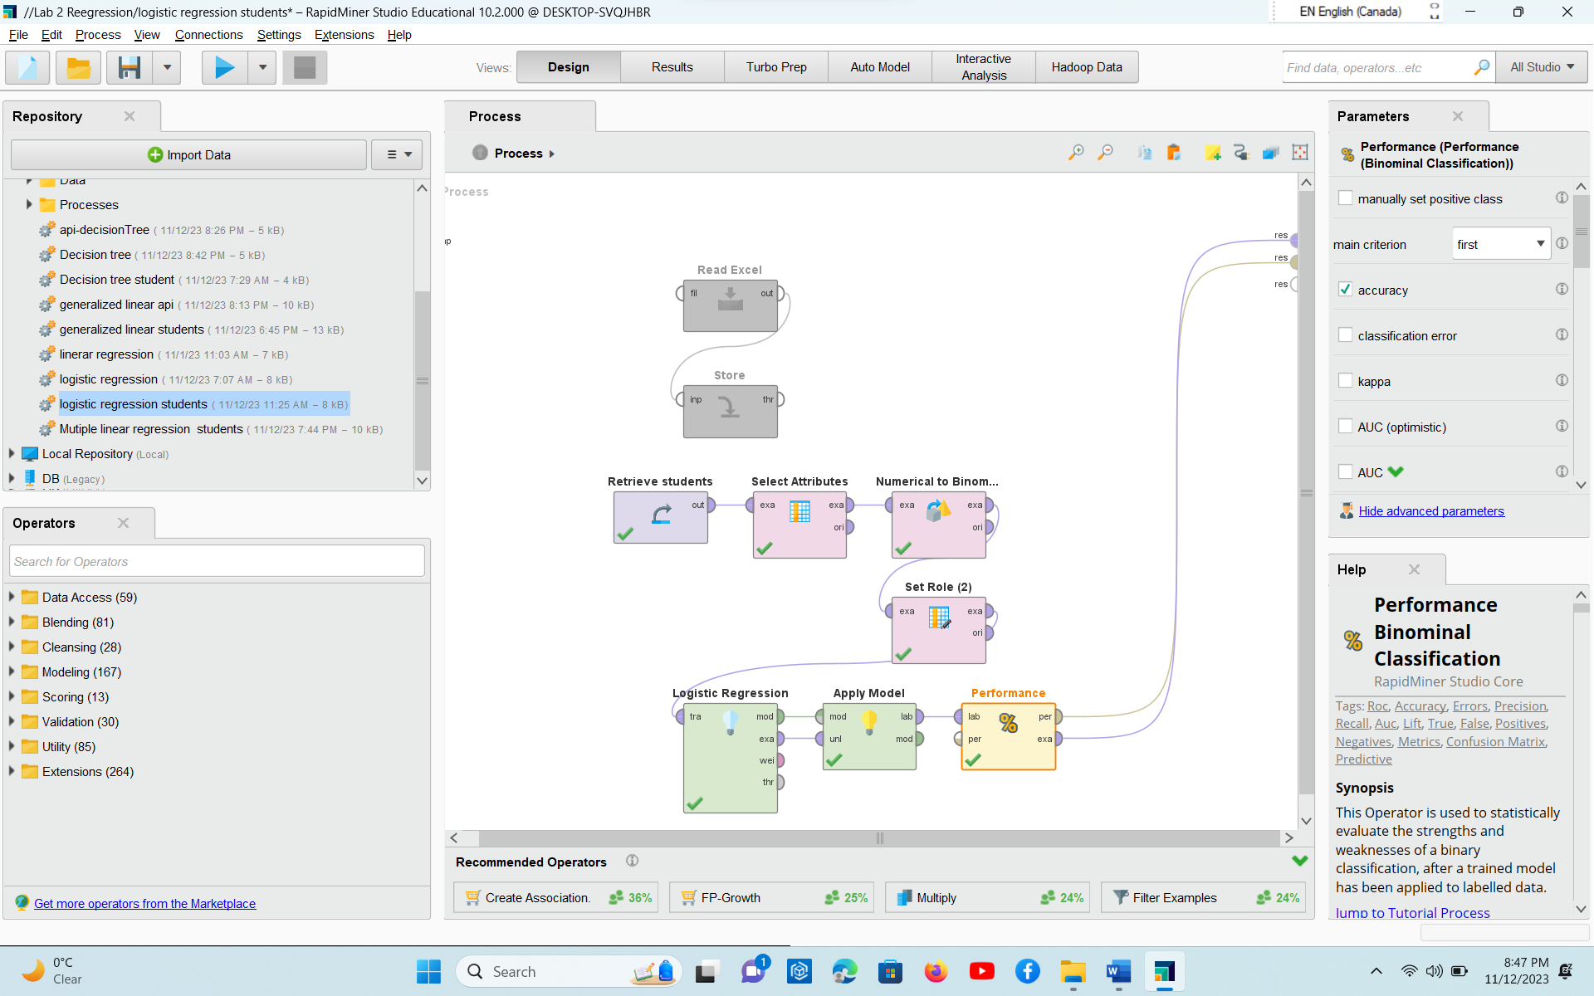

* Running Output/Results from RapidMiner (or any other tools/ languages) 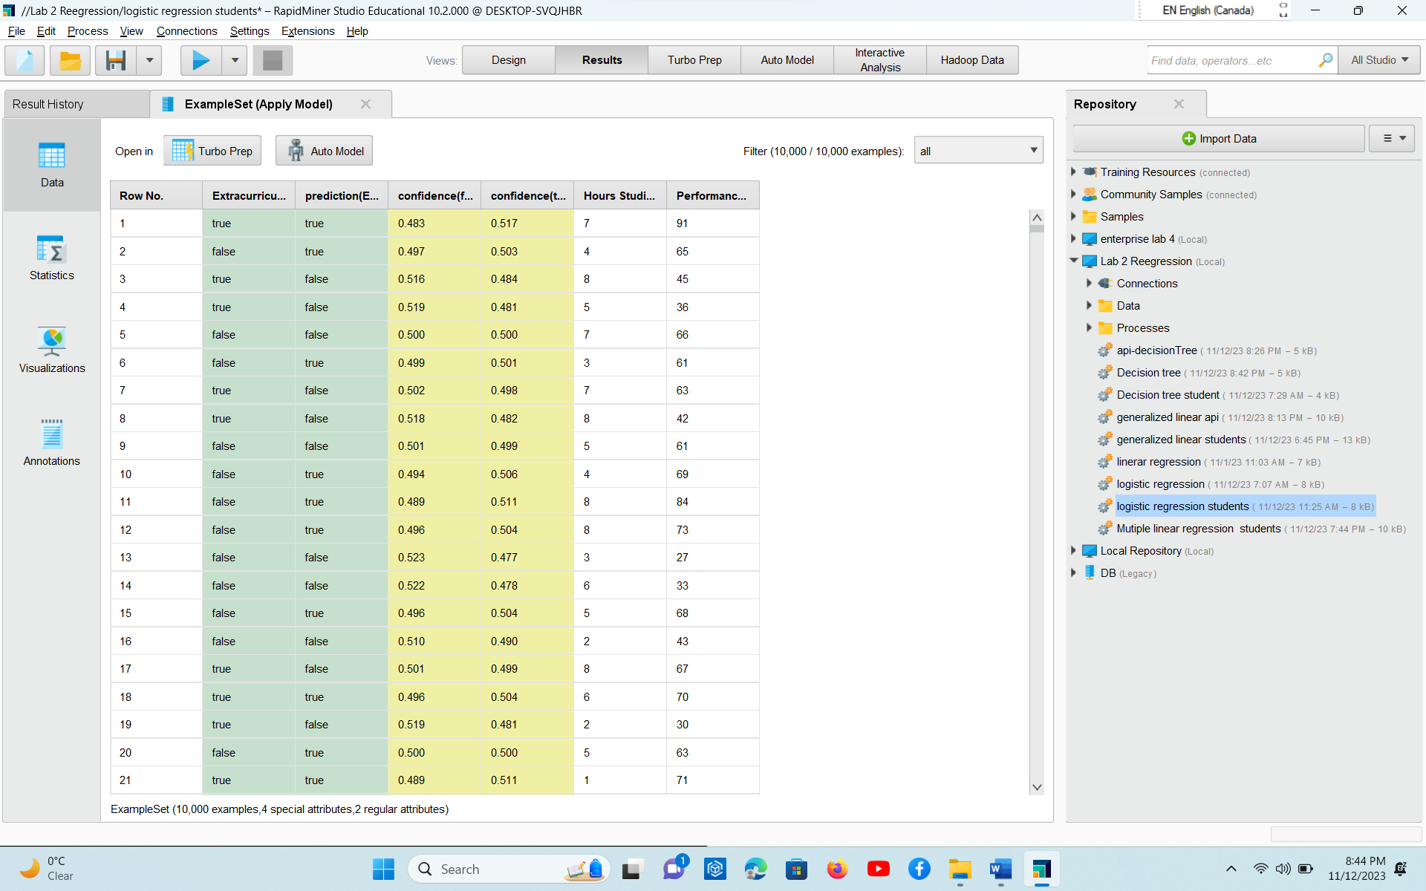
* 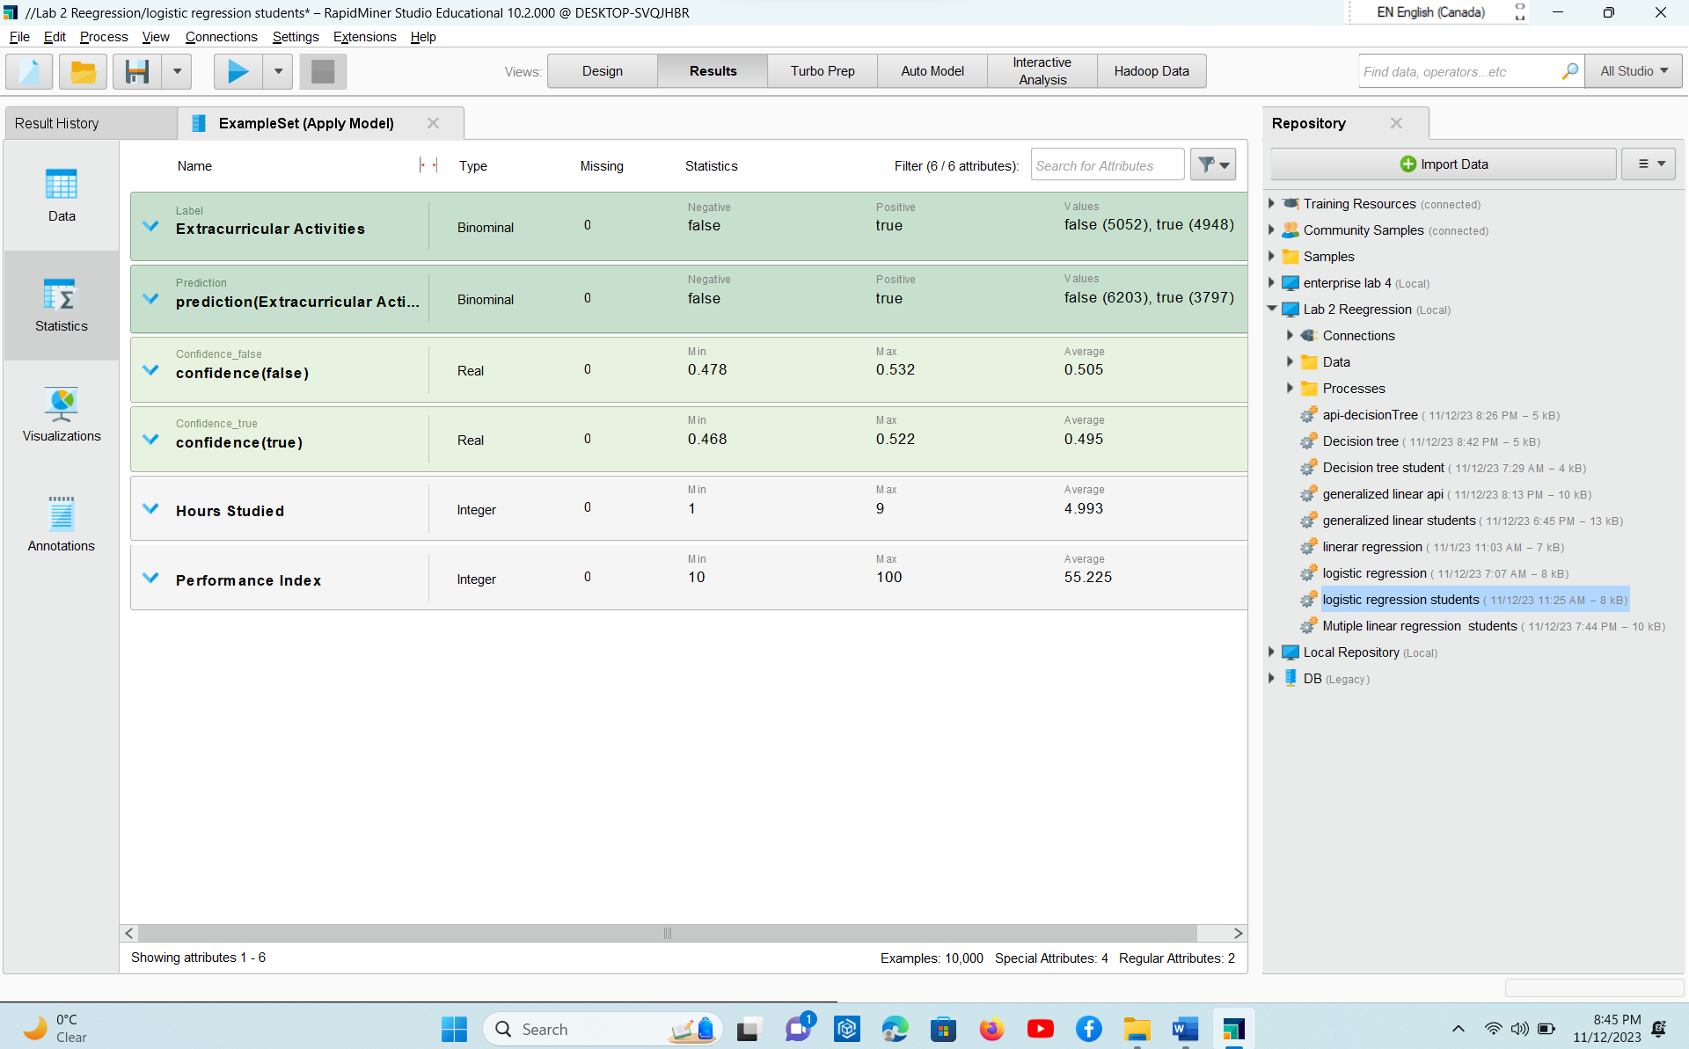
* 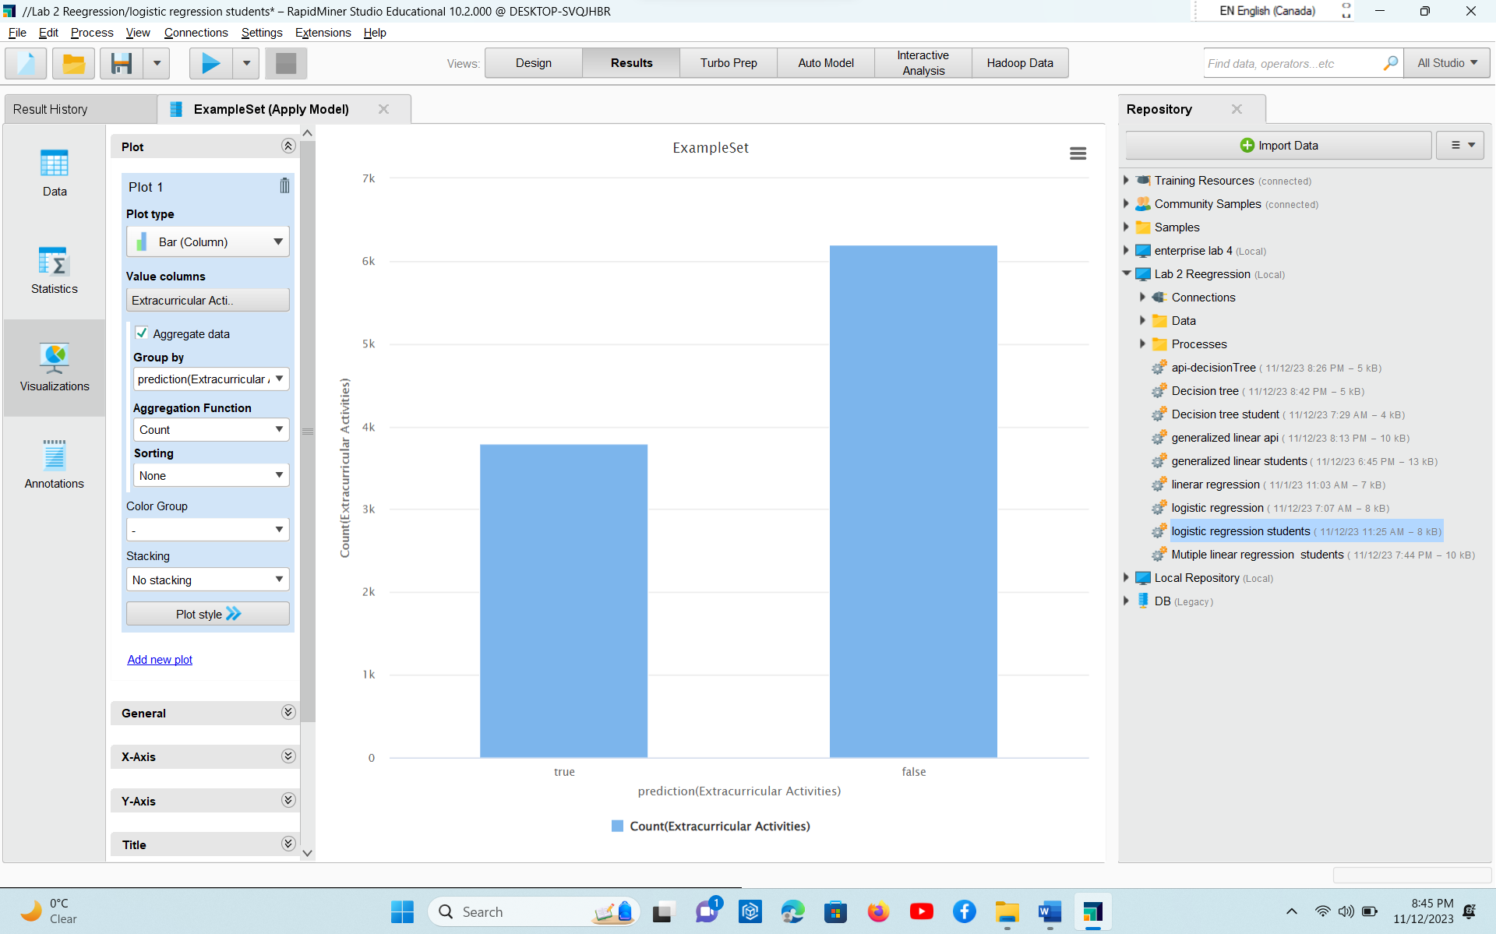
* 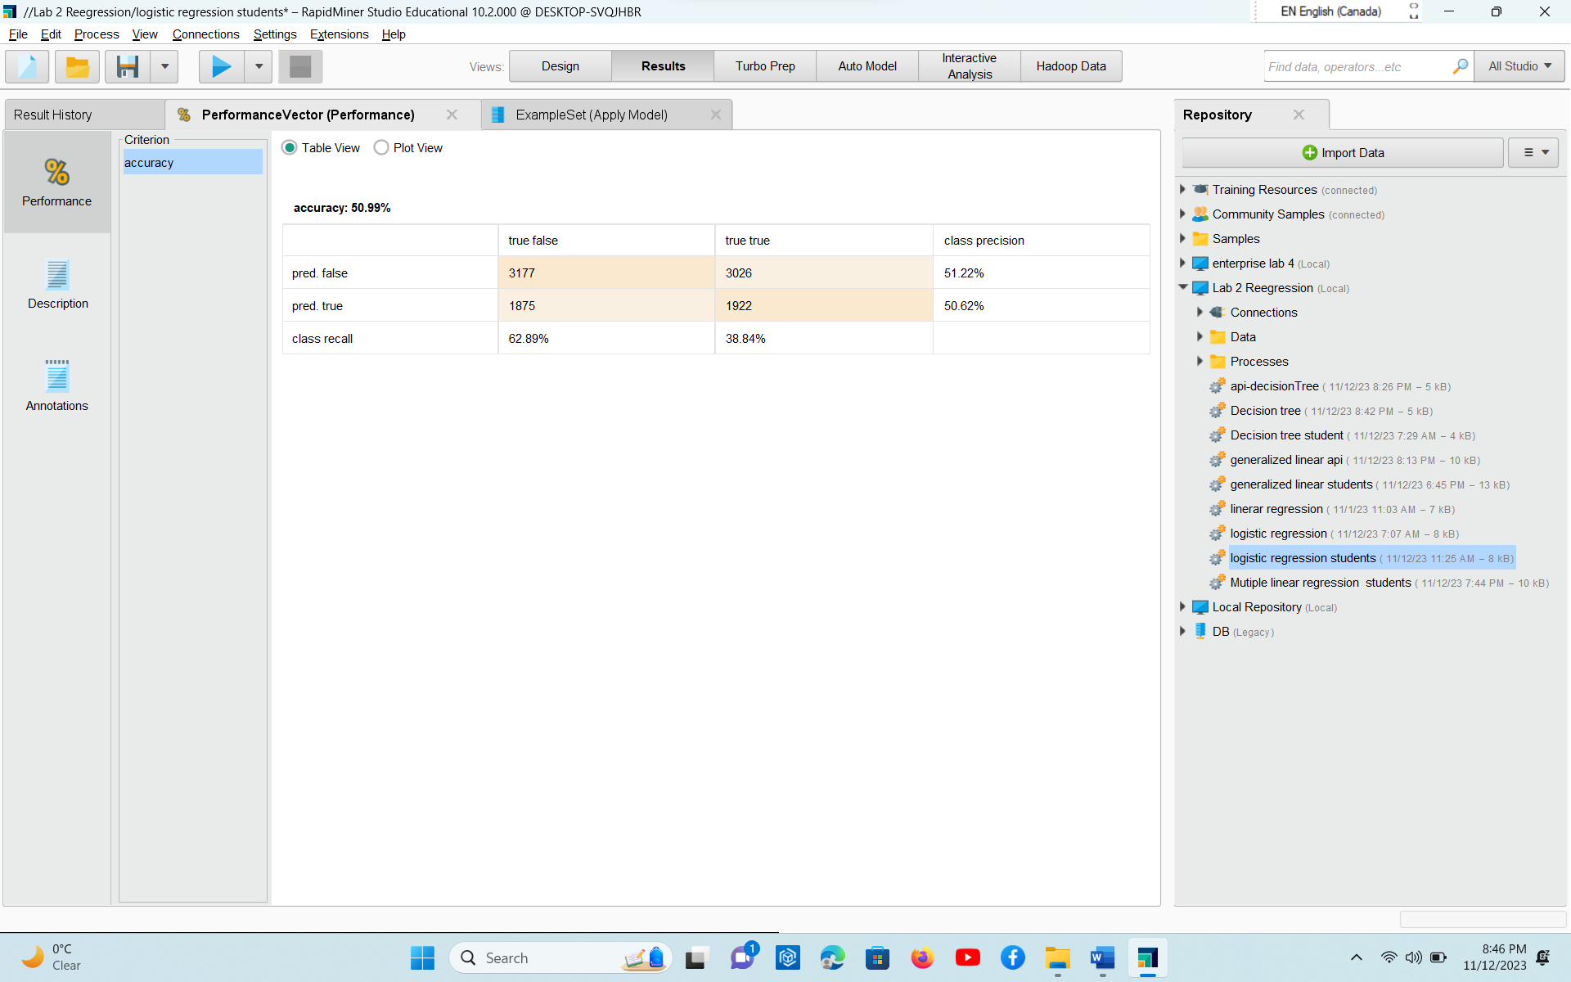
* Analysis part written in word with explaining the working and why you choose the given dataset.
* Full screenshots of your working including the process design
* Explanation on the various operators / steps used within the process

Read excel

Read from excel file

Store Excel

Store as an object

Retrieve student

Take the object stored in repository and use for our requirements

Select attributes

It select a subset of from given file

Numerical to Binomial

Set Role

Change the role of the required attribute

Logistic Regression

Executes Logistic regression model using H2O 3.30.0.1

Apply model

Applies a model on example set

Performance

This operator performs statistical performance evaluation of regressions tasks and delivers a list of performance values of regression task

PART 4: Explain the pros and cons of each model - 10 points

Generalized Linear Regression

1. I give me understandable coefficients
2. It is simple and fast
3. It doesnot assume that residuals are normally distributed

Cons

1. It assumes linear relationship between predictor and responsive variable which may not hold in all cases
2. It may be sensitive to outliners. And these outlines may affect model
3. It may not catch complex non linear relationship in the data

Decision Tree

1. It can model complex non linear relationship in data
2. It doesnot assume any particular distribution of the data
3. It can provide important feature which help to identify variables which are more infuencial in to prerdict target

Cons

1. It Is overfitted and deep. Sometimes we can skip something imp
2. It can be less stable if we do some changes in data
3. It is understandable but sometimes complex trees can be challenging

Logistic Regression

1. It provides probabilities which can be useful when the target is not just classification but it also gives the likelihood of particular outcome
2. It is not overfitted esp when number of features is large as compared to no of observations
3. it works well as the decision class is linear

Cons

1. It assumes linear relationship predictor and log-odds of responsive variable
2. We can may trugle to capture complex non linear relationship
3. It can be sensitive to outliners and it may affect estimated co efficient

Copy of the data that you extracted (.csv/.xls, .xlsx). It can be zipped. You can also provide the url link.

<https://www.kaggle.com/datasets/nikhil7280/student-performance-multiple-linear-regression>

<https://www.kaggle.com/datasets/shivd24coder/ultimate-api-dataset-1000-data-sources>

<https://www.kaggle.com/datasets/willianoliveiragibin/fatalities-in-the-israeli-palestinian>

Your RapidMiner process file (.rmp format). Note: if you are using other tools and languages, please provide relevant files (python, R, Tableau, Power BI, etc.)

**You can go to Kaggle and other sources to search for appropriate dataset**